# MASTERs 2024 Lab Manual

# 24023 LNX3

***Fusing Intelligence into Your Microchip Graphics Suite for Linux® Application Using AI***

**Microchip University**

**Lab Manual for Fusing Intelligence into Your Microchip Graphics Suite for Linux® Application Using AI**

Table of Contents

MASTERs 2024 Lab Manual 1

24023 LNX3 1

Introduction: 4

Conventions 4

Software Prerequisites: 5

Hardware Requirements: 5

Lab 1: Developing a Graphical Application Using EGT with Eclipse IDE 6

Hardware Setup 6

Accessing Target Console 7

Exercise 1: Opening a Template Project and reviewing Properties in Eclipse IDE 9

Exercise 2: Building the Template Project and remotely execute the application 14

Exercise 3: Implementing On-Click Events for Screen Transitions 19

Exercise 4: Customizing Slider behavior and Label Display 22

Exercise 5: Modifying Scrolling Text Animation Direction 24

Conclusion 26

Lab 2 – Implementation of Gesture Recognition with MGC3140 in EGT-Powered Graphical Application 27

Hardware Connection 27

Exercise 1: Observe the terminal for gesture action 29

Exercise 2: Navigate the screen using the Gesture Actions 30

Conclusion 31

Lab 3 - Run AI application (Face Detection) on Target 32

Hardware Connection 33

Exercise 1: Customize GPIO Control Based on Number of Detected Faces 33

Conclusion 35

Appendix A – Procedure for building the image for ATSAMA5D27-WLSOM1 EK using Buildroot 36

*Appendix B - Study and Understand the Classes and Functions used in the Application Code* 39

Appendix C – Usage of argparse and tflite_runtime 42

Appendix D - Study and Understand Python Face detection Application Code 43

Appendix E - Study and Understand popup and GPIO status monitoring code snippet 46

Appendix F – Installing Face.py and graphics application as system services 51

## Introduction:

The purpose of this lab manual is to guide you through the implementation of advanced embedded design techniques using the ATSAMA5D27-WLSOM1-EK board. This lab’s emphasis is on integrating graphical application with AI-powered face detection to enhance security and user interaction. Additionally, it includes incorporation of the MGC3140 Emerald Kit for gesture sensing and utilization of the Microchip Graphics Suite for Linux (MGS) / Ensemble Graphics Toolkit (EGT) for graphical application development.

In this lab, you will be developing an ATM application which involves graphics, AI and a contactless user interface. You will create and manage a GUI using MGS Linux / EGT, control screen navigation using gesture-based actions, and implement a security feature using AI face detection. Specifically, the face detection application will alert the user if more than one face is detected while accessing the GUI, ensuring privacy and security.

By the end of this lab, you will have hands-on experience with:

* Connecting and configuring the ATSAMA5D27-WLSOM1-EK board and the MGC3140 gesture sensor.
* Implementing and managing GUI using EGT / MGS Linux.
* Integrating AI face detection for security alerts.
* Controlling GUI screens with gesture inputs.

This lab manual is designed to provide a comprehensive learning experience without the need for extensive coding. However, detailed comments and appendices are included for those who wish to dive deeper into the code and its functionalities.

**Upon completion, you will be able to:**

* Design your own screen using the EGT framework
* Navigate the screen using MGC3140 (Gesture sensor)
* Interface AI into the Graphical Application

## Conventions

Serial Terminal Commands *CommandName*

**INFO**  Relevant information about a specific topic

**WARNING**  Important information

****Ensemble Graphics Toolkit (**EGT**) is being rebranded and released as **Microchip Graphics Suite for Linux** (MGS Linux). This lab manual continues to refer to the Graphics framework as EGT. **However, in future, MGS Linux must be used for graphical application developments.**

## Software Prerequisites:

* Eclipse IDE for C/C++ Developers
* Buildroot image (version: linux4microchip-2023.10)
  + Prebuilt with AI dependencies and GestIC driver

## Hardware Requirements:

Below is the list of hardware required to complete this lab:

* ATSAMA5D27-WLSOM1 EK ([DM320117](https://www.microchip.com/en-us/development-tool/dm320117))
* MGC3140 Emerald Development Kit ([DM160238](https://www.microchip.com/en-us/development-tool/DM160238))
* 5-inch WVGA LCD DISPLAY ([AC320005-5](https://www.microchip.com/en-us/development-tool/AC320005-5))
* SD Card (2GB+)
* 20-Pin to 6-Pin Adapter
* A Micro-USB cable

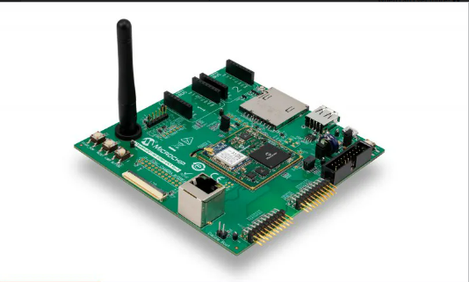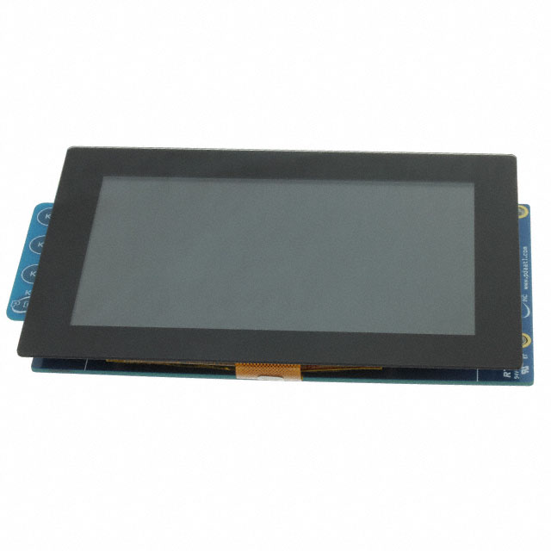

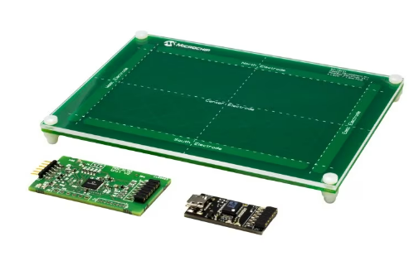

# Lab 1: Developing a Graphical Application Using EGT with Eclipse IDE

The purpose of this lab is to explore EGT functionalities through hands-on tasks using the Eclipse IDE and Buildroot toolchain.

The GUI of the graphical application is pre-designed and exported as an XML file using the Microchip Graphics Suite Composer. This design has been imported to the C++ based UI application. The project is set up in Eclipse IDE and is configured to use buildroot cross-compiling toolchain.

## Hardware Setup

Follow these instructions to complete the hardware setup for LAB 1.

1. Connect the flexible flat cable from the TM5000 WVGA display to the LCD connector (J21) on the ATSAMA5D27-WLSOM1 EK (silver connectors down).

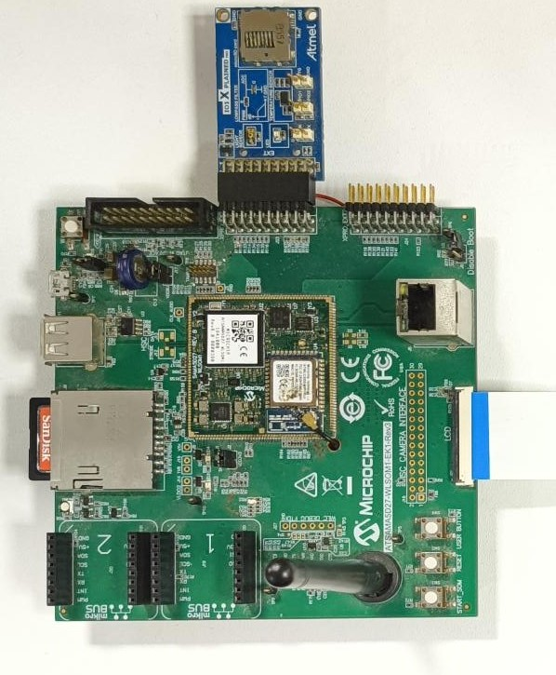

2. Connect theFTDI cableto the UART FTDI Debug Connector(J26) on the ATSAMA5D27-WLSOM1 EK.Ensure that the black wire is connected to the GND**.** Connect the other end of the FTDI cable to the Linux host to monitor boot logs and enter user space commands.

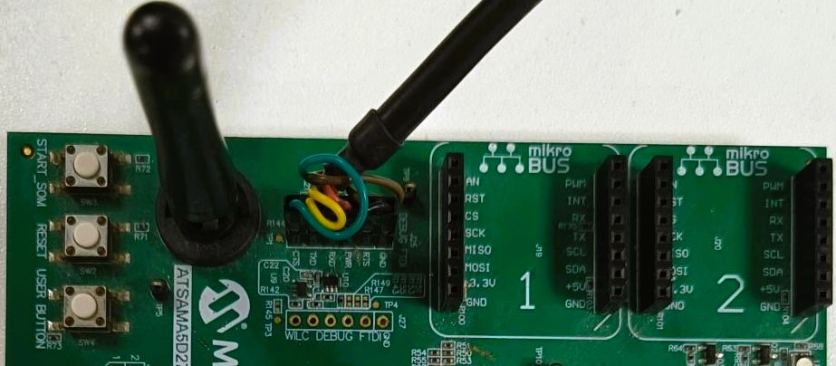

3. Connect the Ethernet Cable to the Ethernet RJ45 connector (J6) on the ATSAMA5D27-WLSOM1 EK and the other end of the Ethernet cable to the Linux host.

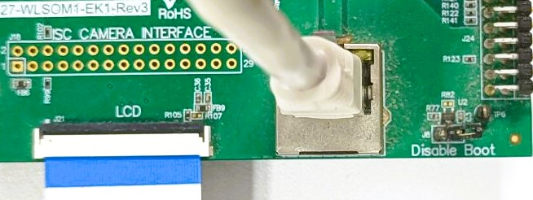

4. Insert the SD card to slot J9 of the ATSAMA5D27-WLSOM1 EK board.

****The SD card provided is flashed with the graphics image, which includes AI dependencies and GestIC driver included in kernel. The necessary resource files used in the Graphics application have been loaded onto the SD card, along with the **ui.xml** file exported using Microchip Graphics Composer.

5. Connect a USB cable to J10 of the ATSAMA5D27-WLSOM1 EK and the other to the Linux host to power the board.

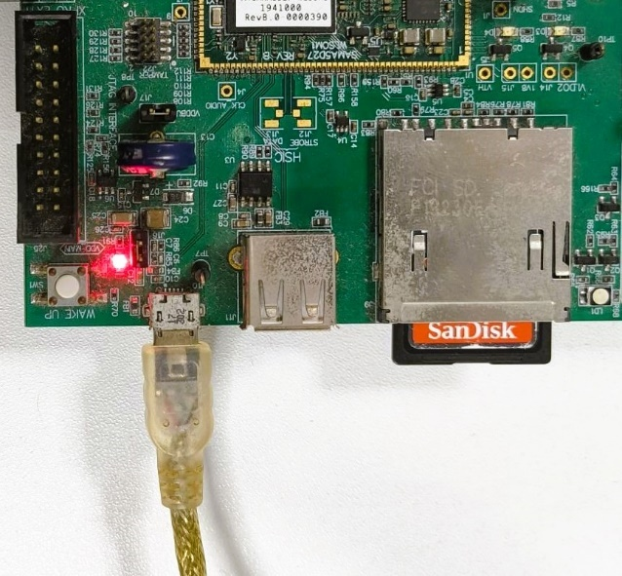

## Accessing Target Console

1. Launch a terminal on the Linux host by clicking on the terminal icon 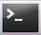.
2. Type “dmesg | grep FTDI” at the command prompt which will list the following information.



In the log message, you can see that the FTDI USB Converter is attached to the **ttyUSB0.**

1. For launching the minicom serial terminal emulator, type “minicom -D /dev/ttyUSB0 -b 115200” on the Linux host terminal.

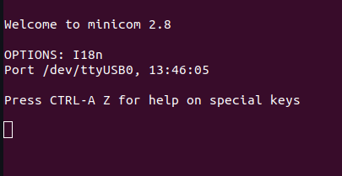

1. Press the START_SOM button on the ATSAMA5D27-WLSOM1 EK. On the terminal, you should see the Linux boot log. Type user login and Password as "root" to login.

****For the initial boot of the board, use the **START_SOM** button. For subsequent reboots, press the reset button. This procedure should also be followed whenever the power supply is disconnected and reconnected.

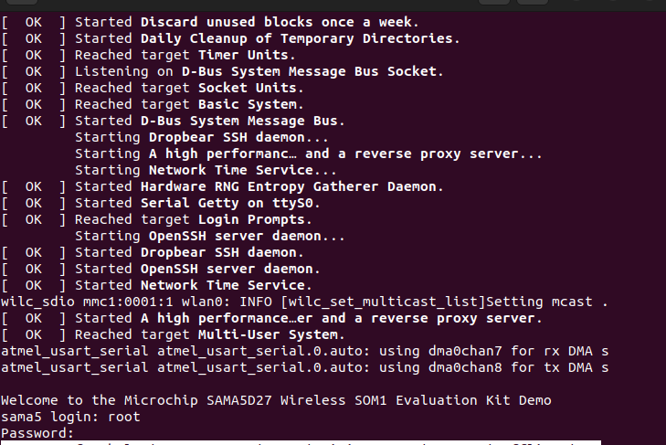

****You have now launched a serial terminal to access the target from the Linux host.

 Use the following command to stop the graphics demo which will run at boot.  
Command**: systemctl stop egtdemo.service**

## 

## Exercise 1: Opening a Template Project and reviewing Properties in Eclipse IDE

In this exercise, you will learn how to open a template project using Eclipse IDE and explore the source code and project properties that have already been set.

**Procedure:**

Step 1:On the Linux host, click on the "**Show Applications**" icon (a grid of dots at the bottom-left corner), then type "Eclipse" in the search bar and select the Eclipse IDE.

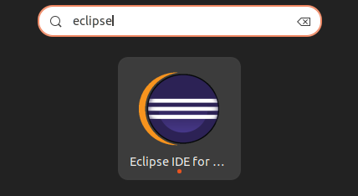

Step 2:Upon launch, Eclipse will prompt you to select a workspace directory. Click on Browse, **choose /home/masters/lnx3/eclipse-workspace** as the workspace, and then click on the Launch button. Eclipse will launch the workspace and display the welcome screen.

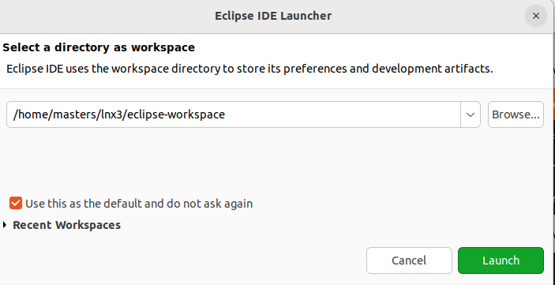

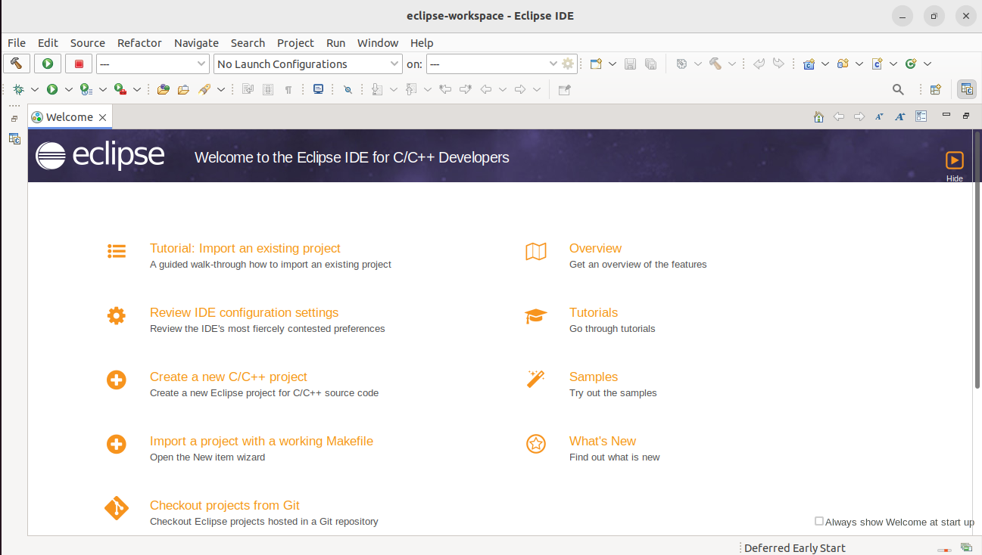

Step 3:To import the Template Project, Click on **File > Import**. In the “**Import Window**”, from the **General** category, **select Existing Projects into Workspace**, and click **Next**. In the next window, in **Select root directory**, point to the directory given below and click on **Finish**.  
Directory: **/home/masters/lnx3/eclipse-workspace/LNX3_MASTERS**

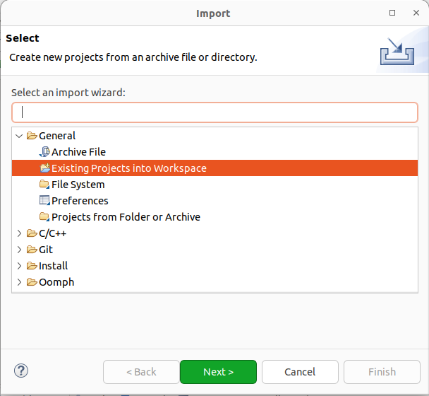

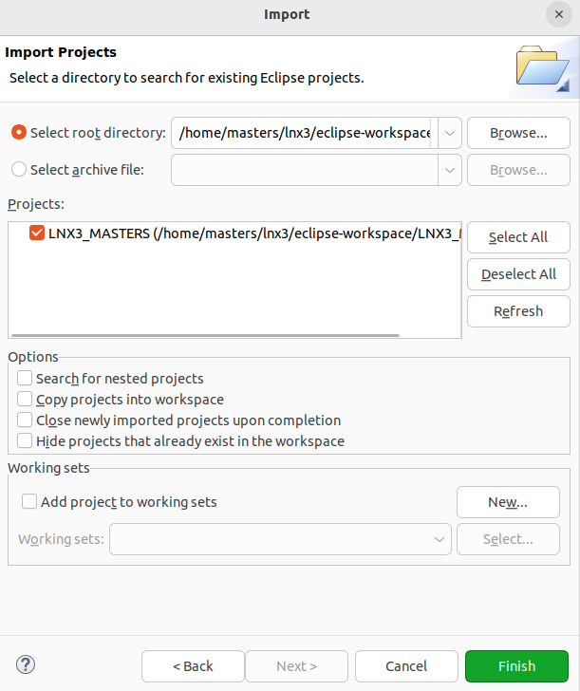

Step 4:Open the **lnx3_masters_egt.cpp** source file from the **LNX3_MASTERS** project to see that the XML file generated by the MGS Composer loads the UI.

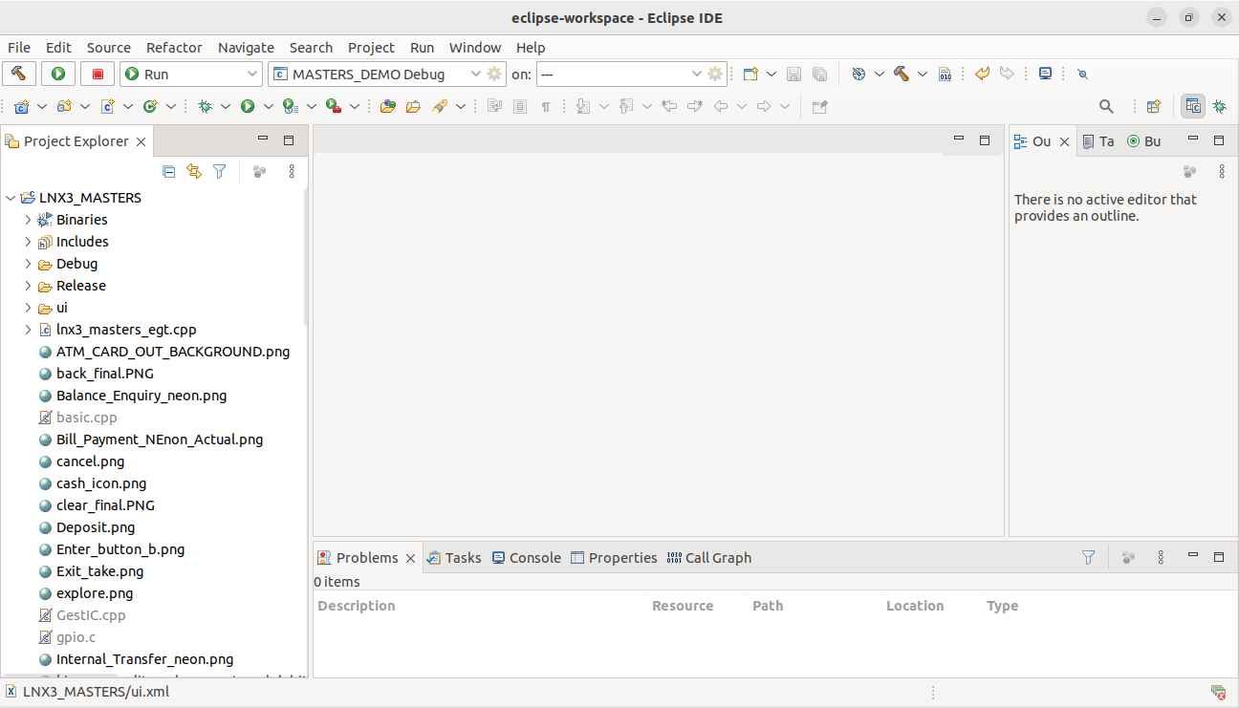

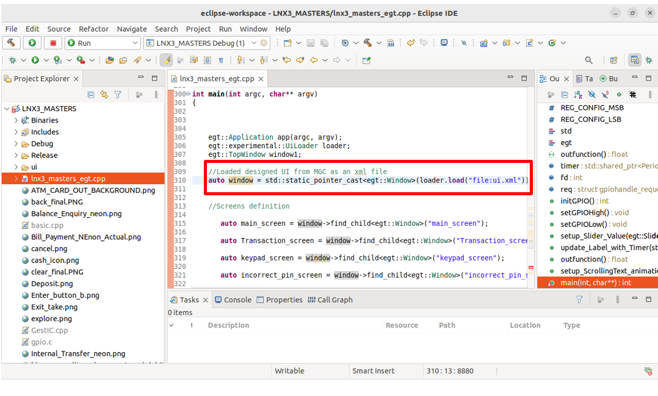

Step 5:To view the Project Properties which has already been set, hover over **LNX3_MASTERS** project**, right-click** and select **Properties** from the menu at the bottom. A “**Properties for LNX3_MASTERS**” window will open as shown below.

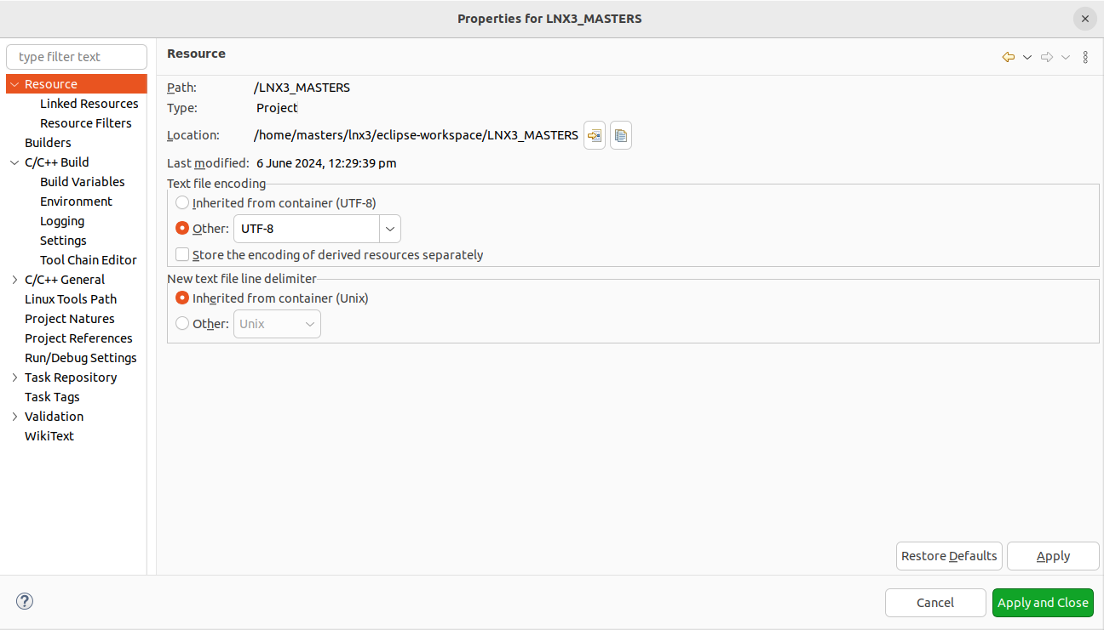

Step 6:In the left-hand pane of the Properties window, select **C/C++ Build > Tool Chain Editor.** Ensure that the **Current toolchain** dropdown box has **Cross GCC** selected.

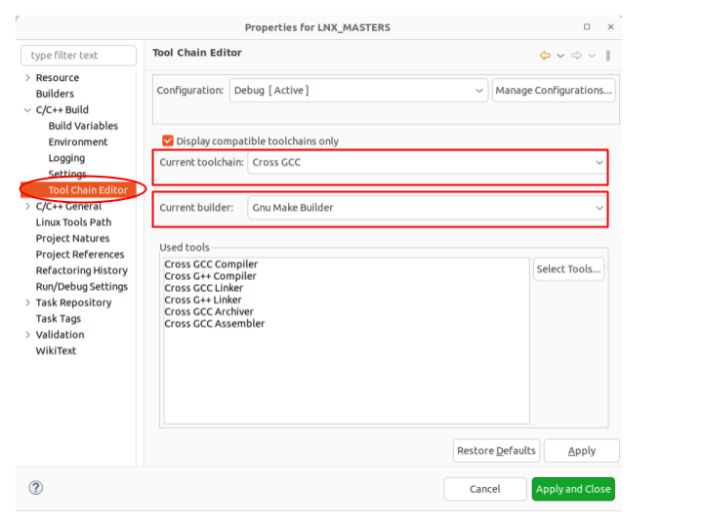

Step 7:Next, select **C/C++ Build > Settings.** On the **Tool Settings** tab, select **Cross Settings**. Review the buildroot cross-compiling toolchain path.

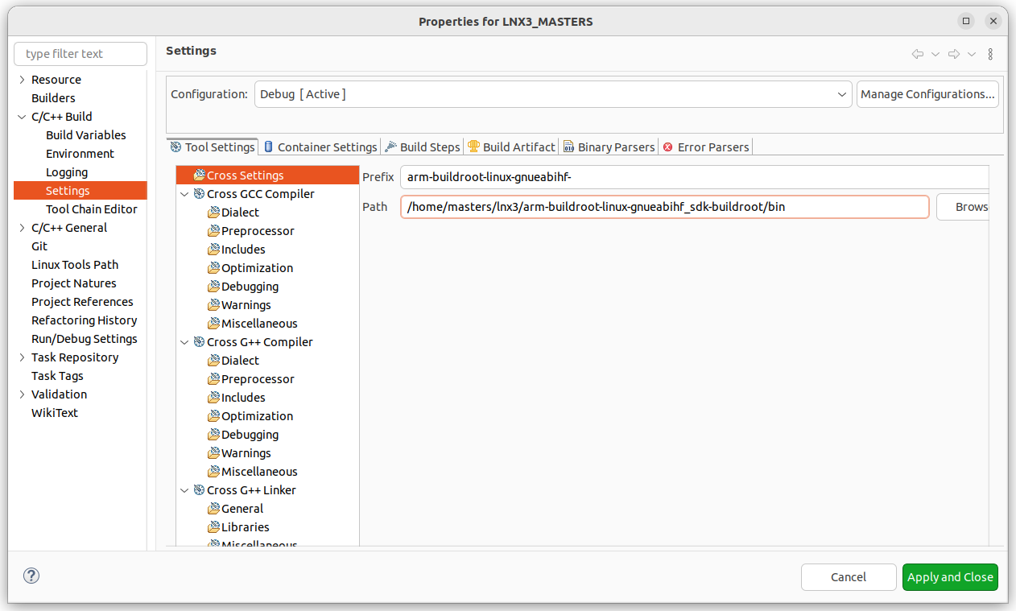

**Prefix: arm-buildroot-linux-gnueabihf-  
Path: /home/masters/lnx3/arm-buildroot-linux-gnueabihf_sdk-buildroot/bin**

The toolchain settings for the project which are pre-configured, have been ****reviewed. Additionally, all other build properties such as Cross G++ Compiler and Linker flags have been set. Furthermore, the dependencies have been configured using the pkg-config tool. For more details about properties settings, please refer to the following page: [Ensemble Graphics Toolkit: First Application Using Eclipse IDE](https://developerhelp.microchip.com/xwiki/bin/view/software-tools/linux/egt-eclipse/)

## Exercise 2: Building the Template Project and remotely execute the application

In this exercise, you will learn how to build the project and to run the application on the ATSAMA5D27-WLSOM1 EK board remotely using SSH connection.

**Procedure:**

Step 1:Hover over the LNX3_MASTERS project in the Project Explorer, right-click and select the **Build Configurations** and click on **Build All** from the menu or click on the **Build icon** in the toolbar.

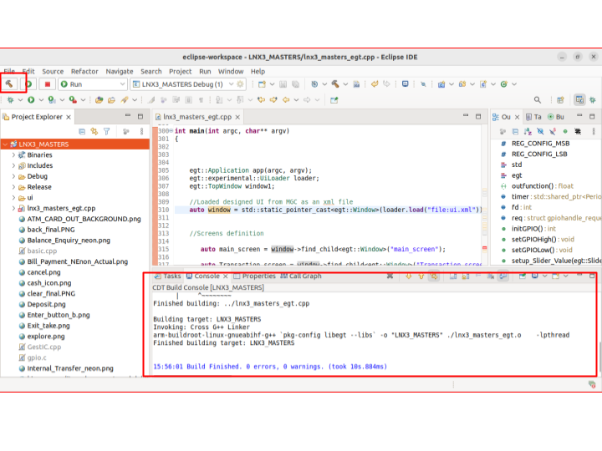

The console window at the bottom pane will display the build progress.

****To **remotely execute** the application on the target, the **SSH Connection** must be established between the target and the Linux host.

Step 2:To run the project, the required properties have already been configured in the Eclipse IDE. These configurations will establish a connection between the target and the Linux host through an SSH connection.

Follow the steps below to configure the run properties for the target:

* + - Hover over the **LNX3_MASTERS** project, right-click and select **Run As > Run Configurations…** from the menu.
    - In the left-hand pane, double-click on **C/C++ Remote Application**. If the **C/C++ Application Path** is not specified, type **Debug/LNX3_MASTERS** as shown in the image below.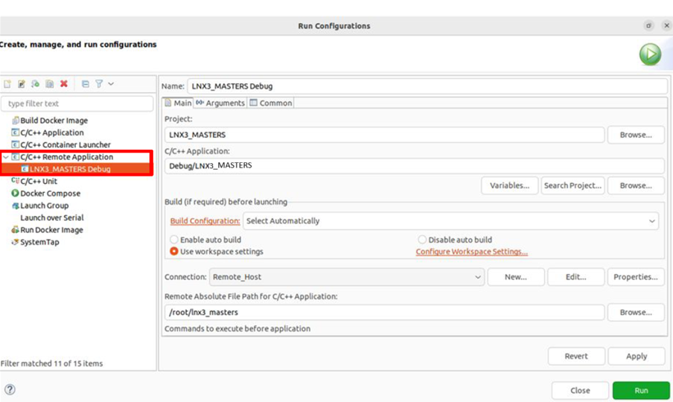
    - To set up an SSH connection with the target, click on the **New…** button. A **Create a** **New Connection window** will appear. For connection type, select SSH from the dropdown box and click on the OK button. A **New Connection** window will appear, as illustrated in the image below. Enter the details mentioned below and then click **Finish**.

**Connection name: Remote Host  
Host: 10.0.0.20  
User: root**

Select **Password based authentication**

**Password: root  
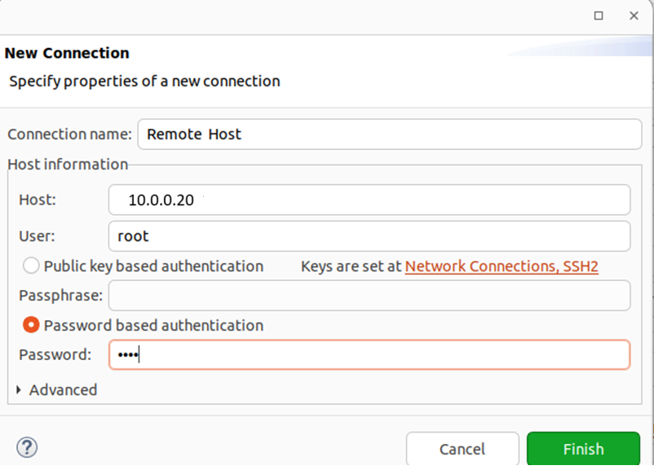**

Step 3:In the **Run Configurations** tab, enter the ‘Remote Absolute File Path for C/C++ Application’ as **/root/lnx3_masters**. This is the location where the lnx3_masters_egt.cpp executable will be loaded and run on the ATSAMA5D27-WLSOM1 EK.

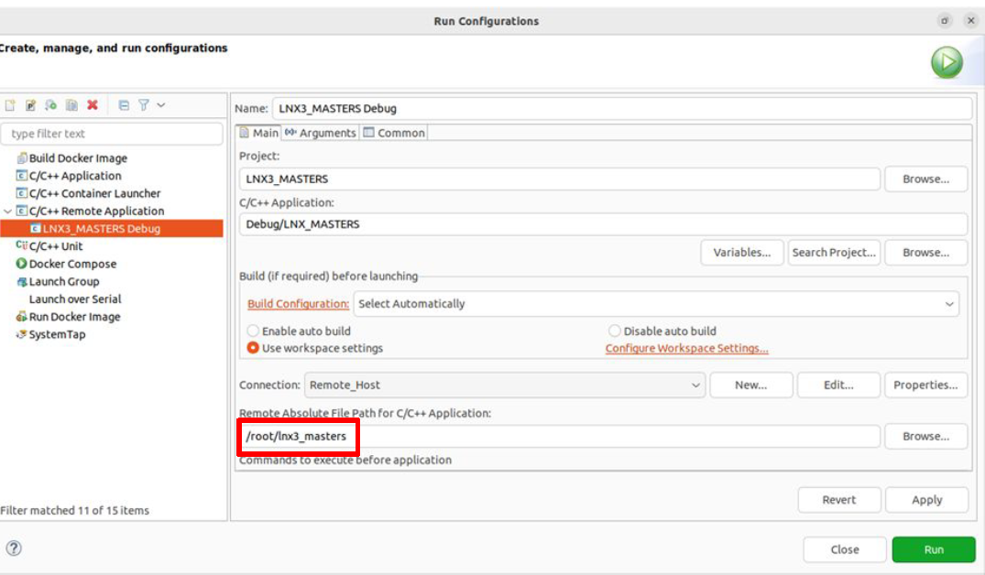

Step 4:Click on the **Run** button. Observe the WVGA display connected to the target:

****When running the application on the target remotely for the first time in the Eclipse IDE, you might encounter an SCP authentication window pop-up for verifying the authenticity of the host. Please select "Yes" to authenticate and proceed with the process.

****When running the project for the first time in the Eclipse IDE, you might encounter a **"org.eclipse.remote.core.exception.RemoteConnectionException"** error. If this occurs, please close the error window and run the project again.

The lnx3_masters_egt.cpp executable is running remotely on the target.

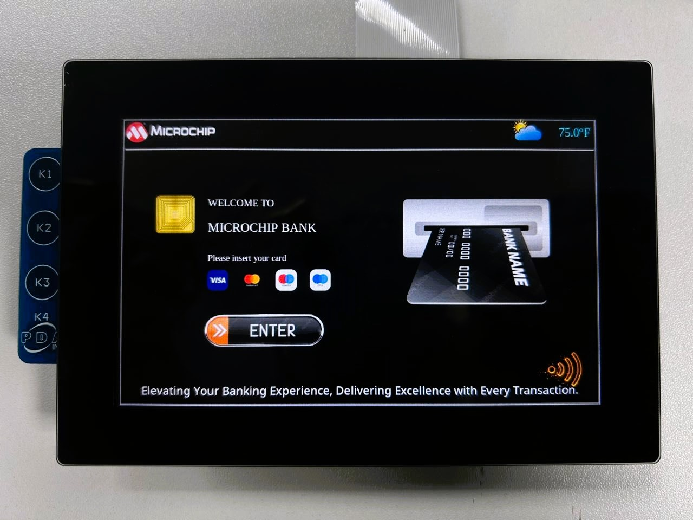

Clicking the "Enter" button will allow you to navigate from the main screen to the transaction screen, which we will implement in the next exercise.****

Step 5: To **stop the current execution** and run other programs on the ATSAMA5D27-WLSOM1 EK, follow the procedure mentioned below:

* From the target console, type the command **ps -a** to list the processes currently running.
* Identify the **process ID (PID)** of the process for **/root/lnx3_masters**.
* Execute the command **kill -9 <PID>** to terminate the process with the identified PID.

This will stop the program running on the target allowing you to build and run other programs.

## Exercise 3: Implementing On-Click Events for Screen Transitions

In this exercise, you will learn how to implement on-click events for a button for screen transitions in the application.

**Procedure:**

Step 1: Open the lnx3_masters_egt.cpp source.

Step 2:Locate the section of code where the button widgets mentioned below are instantiated in the **main function**. These buttons are typically defined based on the names generated from the XML file exported by the Microchip Graphics Composer during the GUI design phase.

**// Define ImageButtons based on XML file name**

auto Enter_button = window->find_child<egt::ImageButton>("Enter_button");

auto Withdrawal_button = window->find_child<egt::ImageButton>("Withdrawal_button");

In the provided code snippet, buttons are defined using auto keyword and find_child method.

Step 3:Inspect the lambda function associated with the **Enter_button** button to manage screen transitions when clicked. This involves hiding all the screens except **Transaction_screen.**

****A lambda function is an anonymous function that can capture variables from its surrounding scope. It allows us to define short functions inline, making the code concise and easier to read. The lambda function used here captures several screen objects by reference (indicated by &).

**// On_click Events**

**// Handles Enter_button click to hide all screens except for Transaction_screen.**

Enter_button->on_click([&main_screen, &Transaction_screen, &keypad_screen, &slider_screen, &incorrect_pin_screen, &Thank_you_screen](egt::Event &) {

main_screen->hide();

**Transaction_screen->show();**

keypad_screen->hide();

slider_screen->hide();

incorrect_pin_screen->hide();

Thank_you_screen->hide();

});

Step 4:Similarly, define the behavior for the **Withdrawal_button** **click event**. This should involve hiding all screens except the **keypad_screen**.

Withdrawal_button->on_click([&main_screen,&window, &Transaction_screen, &keypad_screen, &slider_screen, &incorrect_pin_screen, &Thank_you_screen, &input, &input_val](egt::Event &) {

**// TODO: Write the actual withdrawal_button event handling code to hide all the screens except the keypad_screen**

**// The below code ensures that when entering keypad screens, any existing input data in the text box is cleared and the value is set to zero.**  
 input.clear();

input_val=0;

});

Before proceeding to build and run the new program on the target, ensure to stop the current remote execution as outlined in **Step 5 of Exercise 2.** Only then the new program will be executed on the target.

Step 5:Finally, build the **LNX3_MASTERS** project and run the configurations as instructed in Exercise 2.

Step 6:Verify the screen transition upon clicking the **Withdrawal_button** as shown in the image below.

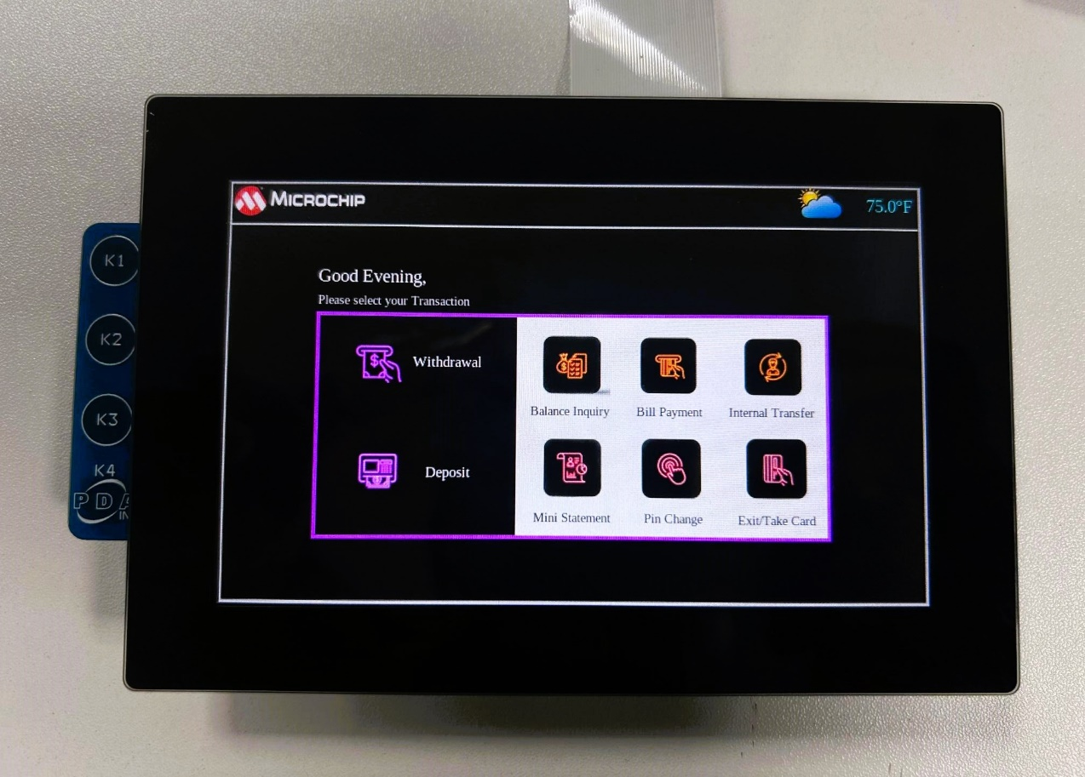

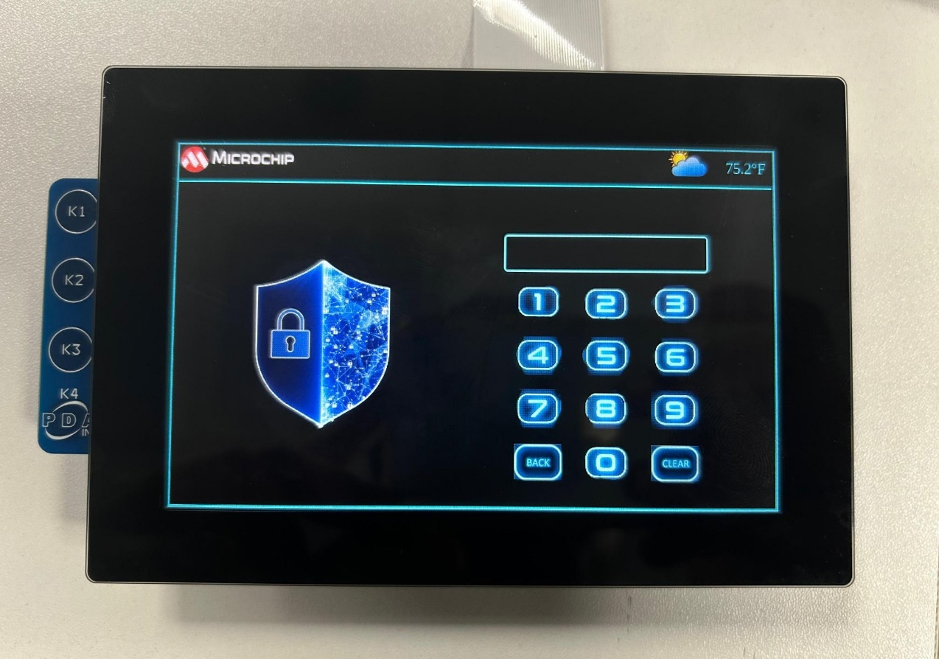

****In this exercise, we first find **Enter_button**, which is an **ImageButton** child with the identifier 'Enter_button’ and set up an **on_click event handler** to manage the visibility of various screens. Then, we find **Withdrawal_button** with the identifier 'Withdrawal_button' and set up **its on_click event handler** to handle screen transitions.

****Password for this application is “1234”

## Exercise 4: Customizing Slider behavior and Label Display

In this exercise, you will learn how to update a label to display the adjusted slider value. You will connect the slider's value change event to a lambda function that ensures the slider value is a multiple of the step increment and updates the label accordingly.

**Procedure:**

Step 1:Open the **lnx3_masters_egt.cpp** source file.Step 2:Locate the **setup_Slider_Value** function, where the logic for updating the slider value according to the step_increment variable has been implemented.

Step 3:Understand the code logic and change the **step_Increment** variable value to 200 by locating it in the **setup_Slider_Value** function.

**// TODO: Modify the step increment value to 200.**

const int step_increment = 100;

Step 4:Replace the placeholder code within the **setup_Slider_Value** function with the actual implementation according to the instructions provided below.

****The **setup_Slider_Value** function customizes the behavior of a slider widget by adjusting its value based on a specified step increment and ensures that a label displays the correct, adjusted slider value. This function connects an event handler to the slider's value change event, dynamically updates the slider's value to a multiple of the step increment and updates the label to reflect this value.

void setup_Slider_Value(egt::Slider& slider, std::shared_ptr<egt::v1::Label>& label)

{

**int step_increment = 100;**

// Connect value change event of slider to update label and slider value

slider.on_value_changed([&label, &slider, step_increment]()

{

**// TODO: Modify the code line below to update the label with the slider value**

**// Hint: Concatenate the slider.value to the existing “$” String**

**// Example: If the slider value is 200, the label should display "$ 200"**

label->text("$ ");

int value = slider.value();

// Adjust the value to be a multiple of step_increment within the range of 0 to 1000

value = std::max(0, std::min(1000, (value / step_increment) * step_increment));

// Update the slider's value

slider.value(value);

});

}

****Before proceeding to build and run the new program on the target, ensure to stop the current remote execution. Only then new program can be executed on the target.

Step 5:Finally, build the LNX3_MASTERS project and run the configurations as instructed in Exercise 2.

**Updated Codeline: label->text(“$ “ + std::to_string(slider.value()));**

Step 6:Verify the slider step increment upon sliding. The label shows the new slider value as shown in the below image.

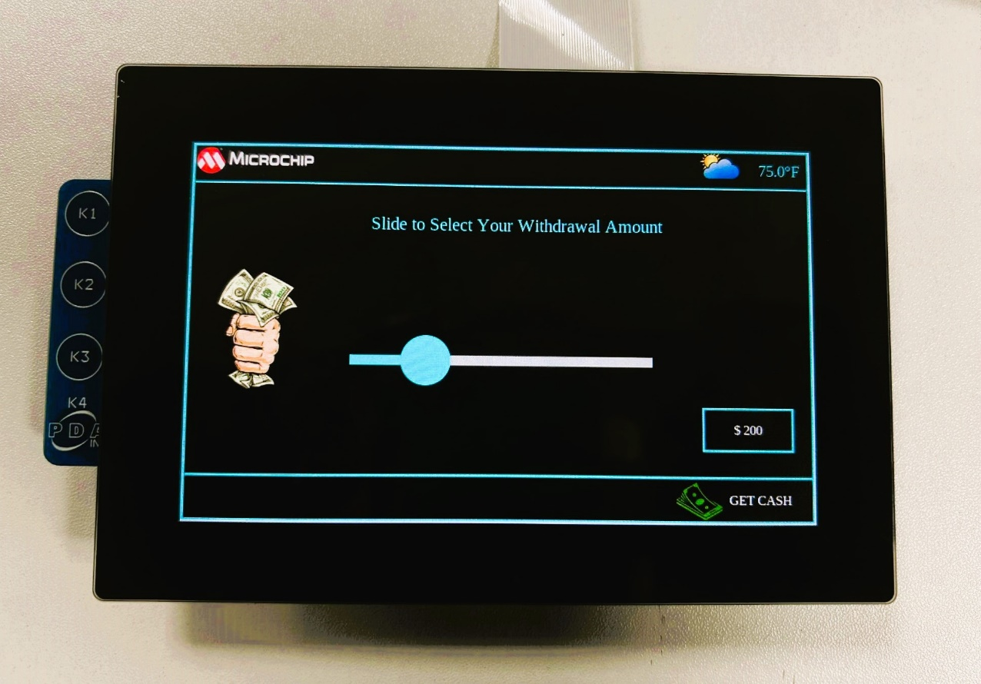

200

## Exercise 5: Modifying Scrolling Text Animation Direction

In this exercise, you will learn how to change the direction of the scrolling text animation from right-to-left. You will modify the scrolling text animation to move from left-to-right instead of right-to-left by adjusting the start and end values of the animation parameters.

**Procedure:**

Step 1:Open **the lnx3_masters_egt.cpp** source file.

Step 2:Locate the **setup_ScrollingText_animation** function and review the current implementation to see how the text scrolls from left-to-right in the main screen.

Step 3:The **easing function** used in the animation is defined as follows:

**// Easing function to return the values between start point and end point for progression of animation**

**auto easing_func = [ ](double t) { return t * t; };**

****This lambda function represents an easing function for animations, where `t` is the progression of the animation. It returns the square of `t`, creating an ease-in effect where the animation starts slowly and accelerates towards the end.

Step 4:Understand the code logic and change the direction of animation by changing the start and the end value in the **egt::AutoAnimation** class.

**// TODO: In the instantiation of the egt::AutoAnimation class:**

**// - Replace the current start value scroll_distance with 0.**

**// - Replace the current end value 0 with scroll_distance.**

**// Scroll Distance represents the width of the screen upto which the text can scroll**

auto animation = std::make_shared<egt::AutoAnimation>(**scroll_distance**, **0,** duration, easing_func, [scrolling_text](double value)

{

**// Update the x-position of the scrolling text widget based on the current animation value**

scrolling_text->x(static_cast<int>(value));

});

****Before proceeding to build and run the new program on the target, ensure to stop the current remote execution. Only then new program will be executed on the target.

Step 5:Finally, build the LNX3_MASTERS project and run the configurations as instructed in Exercise 2.

Step 6:Verify the text is scrolling from left to right in the bottom of the main screen.

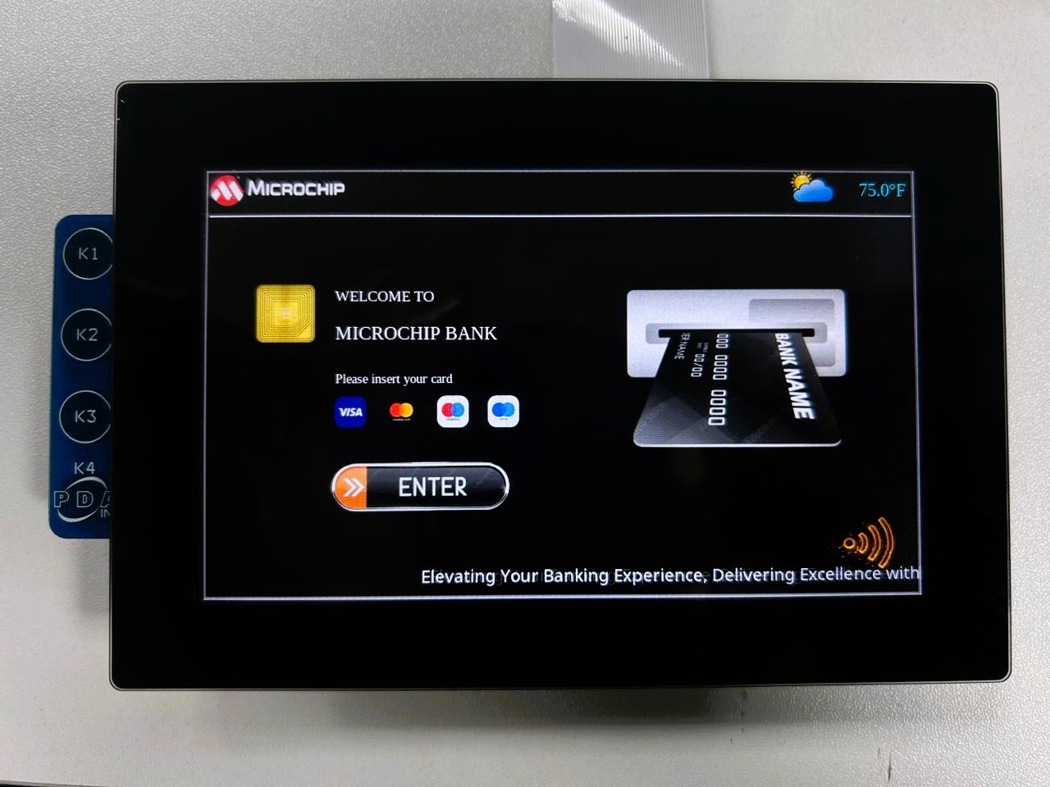

****The **setup_ScrollingText_animation** function configures a scrolling text animation within the main screen of an EGT application. It creates a label widget containing the scrolling text and applies animation to scroll the text horizontally across the screen. The direction of the animation can be specified as either from left to right or from right to left, providing flexibility in the visual presentation of the text. This function enhances the user interface by adding dynamic visual elements to the application

Flow chart:  
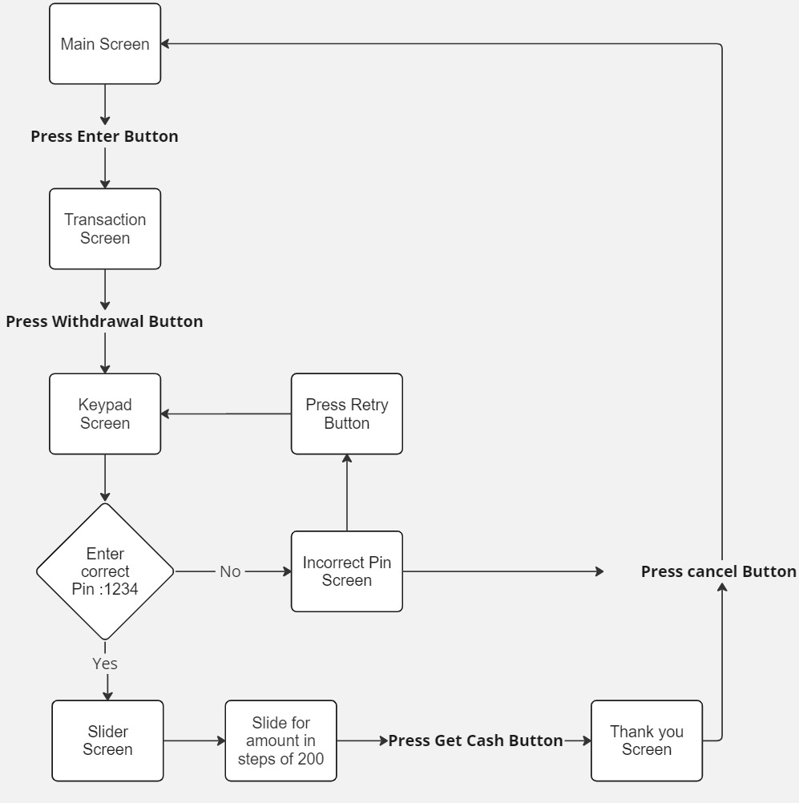

## Conclusion

In this lab, we have successfully built and run applications on the target remotely using SSH, screen transitions are facilitated by on-click event handlers.

Customized slider behavior and label display improves user interaction and feedback in graphical interface. Modifying the scrolling text animation direction gives insight into animation behavior to create visually appealing displays.

Through this lab, you have gained hands-on experience in developing and modifying graphical and functional components using Ensemble Graphics Toolkit (EGT) on embedded systems.

# Lab 2 – Implementation of Gesture Recognition with MGC3140 in EGT-Powered Graphical Application

In this lab, you will integrate the MGC3140 Gesture Emerald kit with ATSAMA5D27-WLSOM1 EK and learn to use the gesture actions to navigate through the LCD screens.

The MGC3140 chip uses an electric field for gesture sensing/position tracking. It is equipped with Microchip’s on-chip Colibri Gesture Suite, which allows gesture tracking on-chip, and eliminates the need for host post-processing in application.

Microchip provides two software development tools for the MGC3140 chip. They are Aurea Software Package (Windows GUI) and MGC3140 Linux Driver (communicates using I2C interface).

In this lab, we will communicate with MGC3140 over I2C interface using a Linux Driver which is integrated in the SD card image. The patch to integrate MGC3140 Linux Driver to the Linux kernel is provided in lab resources.

At the end of the class, you should be able to navigate the EGT screens using the gesture actions from the MGC3140 GestIC module.

## Hardware Connection

1. Power down the board.
2. Connect J3 of the MGC3140 board to the Hillstar sensor as shown in the figure below:

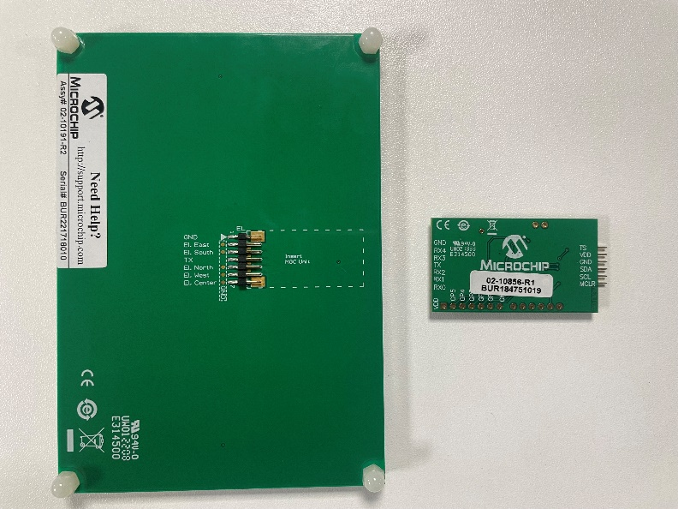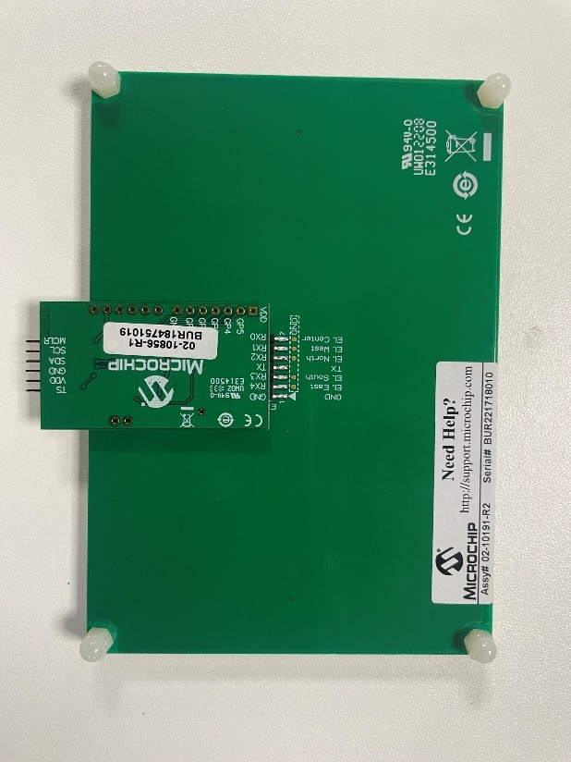

* Connect J2 of the MGC3140 board to XPRO EXT1 of the ATSAMA5D27-WLSOM1 EK board using 20-Pin to 6-Pin Adapter as shown in the figure below.

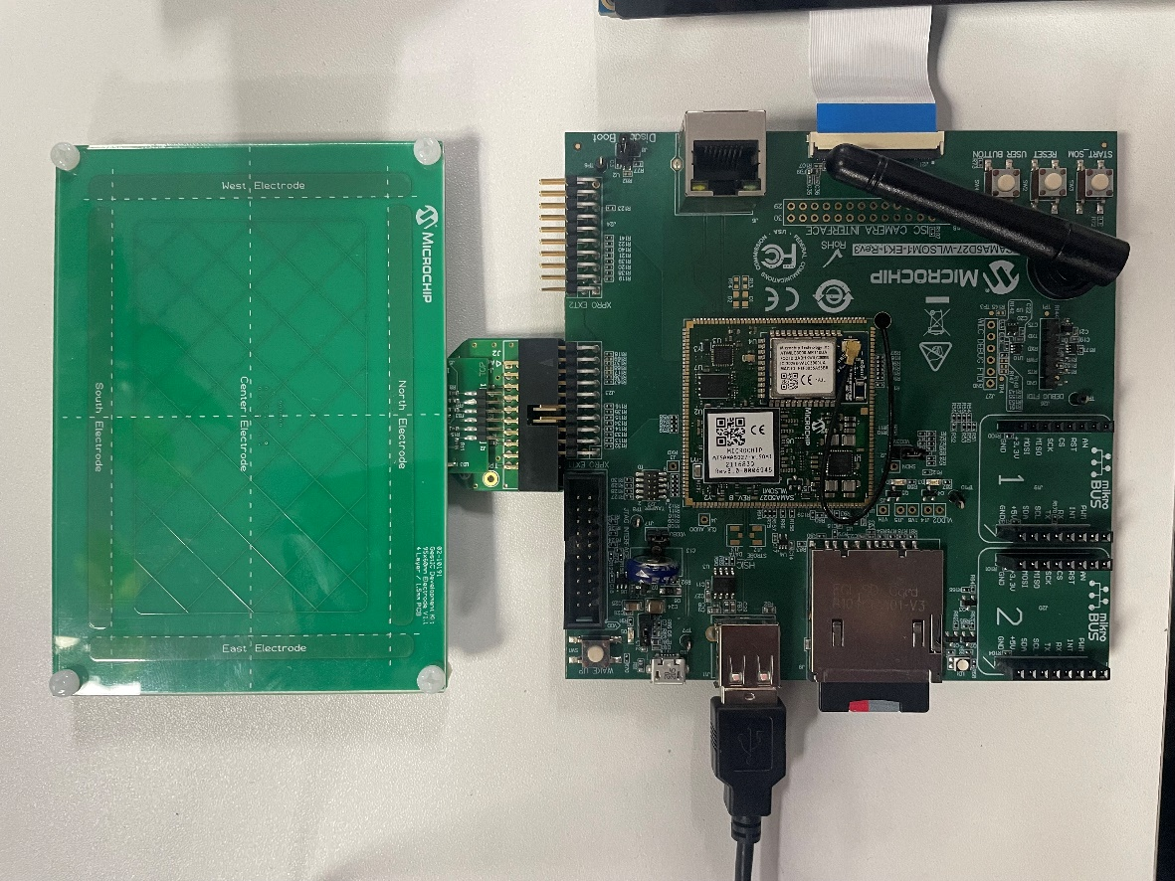

1. Power up the hardware after setup completion and press START_SOM button in the target.

**Final setup:**

The final connection of the setup is as shown below.

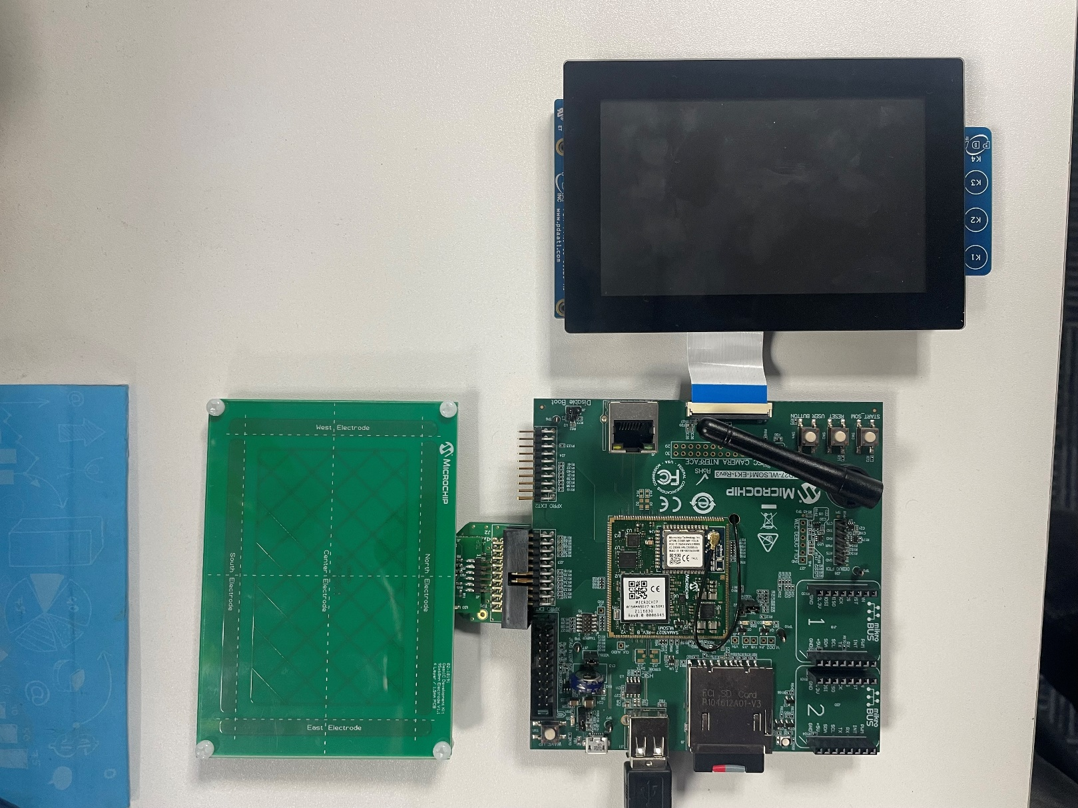

## Exercise 1: Observe the terminal for gesture action

In this exercise, you will use *evtest* tool to test the output of the MGC3140 evaluation board. To interact with the sensor, you need to move your hand from the east electrode to the west electrode, similar to moving from left to right across the sensor.

**Procedure:**

Step 1: Open a terminal window for the target device.

Step 2: Use the *evtest* tool to read data from the MGC3140 sensor.

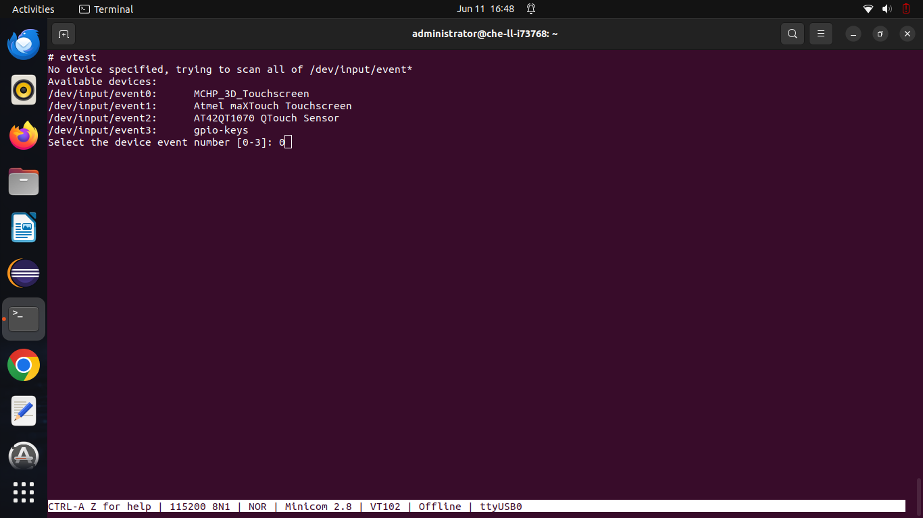

Step 3: When prompted for the device to be scanned, select event number corresponding to MCHP_3D_Touchscreen (Here, it is 0).

Step 4: Once selected, you will see the gestures being captured in the terminal output for each gesture action performed as shown below.

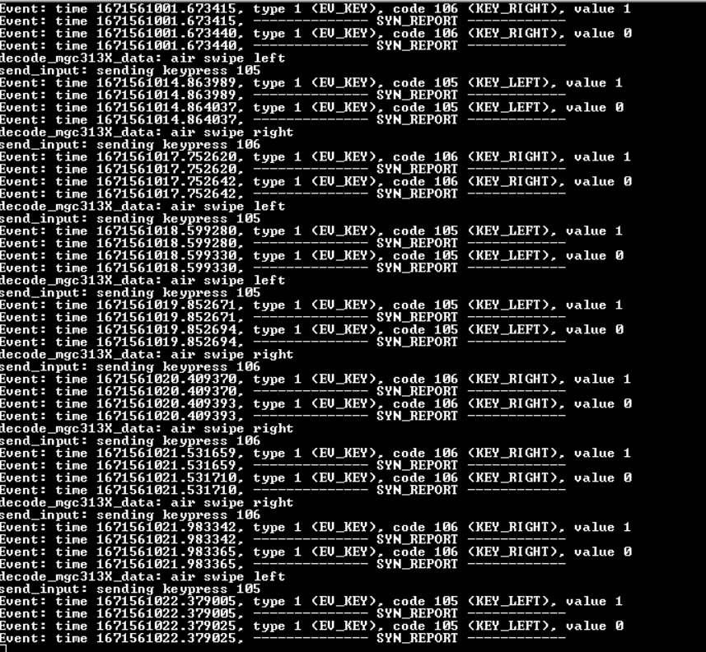

****The sensor values are registered as external events from */dev/input*

## Exercise 2: Navigate the screen using the Gesture Actions

In this exercise, you will capture the gesture event using the event() function and perform screen navigation using the gesture events.

****EGT uses standard Linux input library to parse the external event and maps it to its own keycode system. The keycode mapping of EGT can be found in the link below.

<https://github.com/linux4sam/egt/blob/master/src/keycode.cpp>

**Procedure:**

Step 1: Ensure that the Eclipse IDE from Lab 1 is open. If it has been closed, please follow the steps from Lab 1 to open the working project.

Step 2: Navigate to **window->on_event** in the lnx3_masters_egt.cpp file, where the logic for returning to the main screen on K4 button press has been implemented. For your convenience, the code snippet is provided below:

switch (event.key().keycode) {

case egt::EKEY_RIGHT: {

***//Logic to move to the second screen on a swipe right event***

main_screen->hide();

Transaction_screen-> show ();

keypad_screen->hide();

slider_screen->hide();

incorrect_pin_screen->hide();

Thank_you_screen->hide();

break;

}

**// TODO: Try navigating to the main_screen from the second screen,**

case egt::EKEY_LEFT: {

***//Enter your logic here for swipe left event***

}

default:

break;

}

}, {egt::EventId::keyboard_up});

StSep 3: The key codes for swipe right and swipe left gestures are **EKEY_RIGHT** and **EKEY_LEFT respectively**. Observe the code to move from the main_screen to the second screen using the keycode ‘**EKEY_RIGHT’**(highlighted in blue).

Similarly, you can add the logic for the switch case ‘**EKEY_LEFT’,** for moving to the main screen from second screen (Transaction screen).

The Gesture output logic is used only to traverse between main screen and second screen

## Conclusion

In this lab, you have learned how the MGC3140 can be integrated with the EGT framework and navigate the LCD screens using left and right gesture events.

# Lab 3 - Run AI application (Face Detection) on Target

The purpose of this lab is to demonstrate the implementation of face detection using TensorFlow Lite on the ATSAMA5D27-WLSOM1 EK board.

In this lab, you will run a face detection application written in Python, located in the /root directory. You will modify the application code to customize the detection threshold. The application captures input from a USB camera, processes the frames to detect faces, and controls a GPIO pin based on the number of faces detected. This GPIO pin will later be used to control the graphics application.

The following flow explains how the face detection data is used to control the GPIO status, which in turn controls the graphics application.

By the end of this lab, you will have a hands-on understanding of how to run a face detection application on the ATSAMA5D27-WLSOM1 EK board.

## Hardware Connection

1. Connect the USB camera to the USB port (J11) on the ATSAMA5D27-WLSOM1 EK board as shown in the image below.

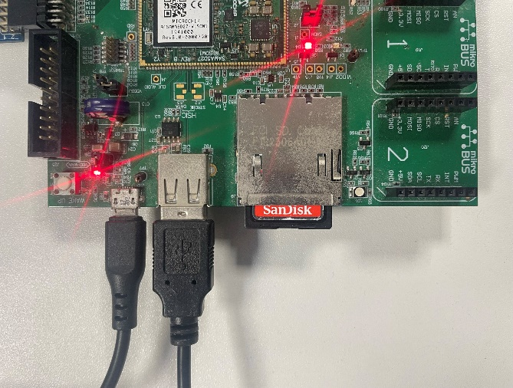

1. Open a serial terminal on the target using minicom as explained in the initial setup.

Enter the following command : *minicom -D /dev/ttyUSB0*

1. Enter the command: “lsusb” and look for the USB camera in the list of connected devices. The camera should be listed with its details, indicating successful detection.

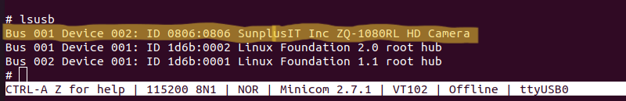

* Connect PD12 to PD13 this is done internally in 20-Pin to 6-Pin Adapter.

The PD12 pin is set by the Face.py Python script when more than 1 face is detected. The PD13 pin is monitored by the graphical application. By connecting the pins PD12 and PD13, we establish a communication between the Python script and the graphical application.

### Exercise 1: Customize GPIO Control Based on Number of Detected Faces

In this exercise, you will modify the code in the face detection script to control a GPIO based on the number of faces detected. The graphical application monitors the status of this GPIO to learn the number of faces detected. If more than 1 face is detected a warning pop-up window is displayed.

You can also use IPC mechanisms such as shared memory, pipes, or message queues to communicate between the Python script and the graphical application. Here a GPIO was chosen for its ease of implementation.

**Procedure:**

Step 1: From the target console, run the Face.py script by typing “**python Face.py &**”.You must see the output in the console. If it detects more than one face it will print “**Not Secured**”, else, “**Secured**” is printed.

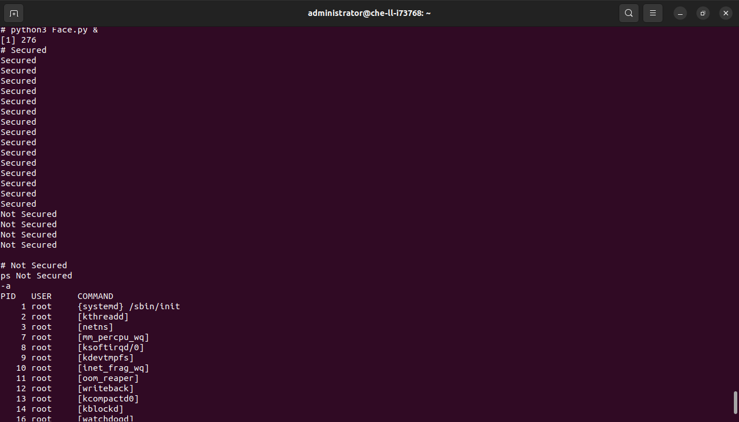

Step 2: The required code to monitor the PD13 pin is already implemented in lnx3_masters_egt.cpp file. The code required to display a warning pop-up window (as shown below) is also implemented:

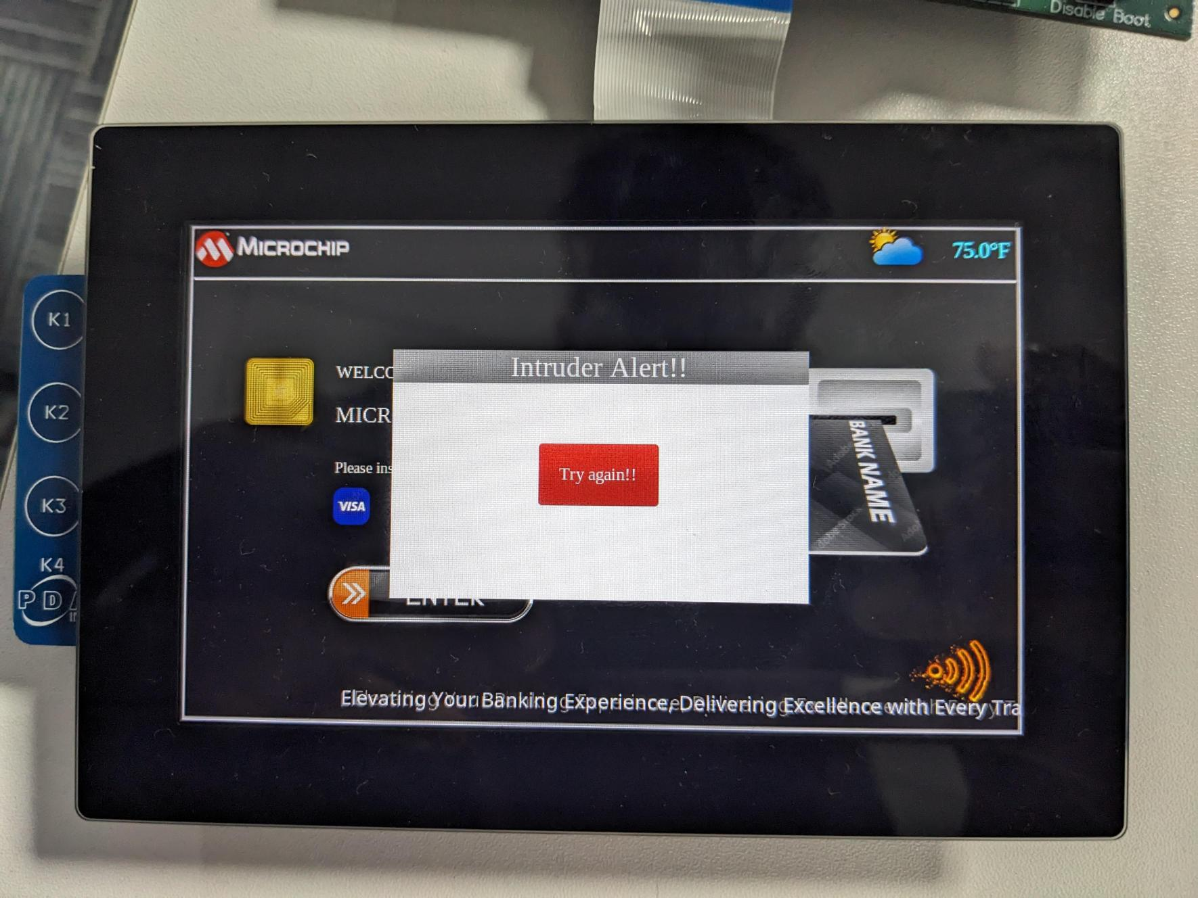

When a single face is detected or no face is detected, the user will have access to the complete GUI. When the number of faces detected is more than one, the Intruder Alert popup will be displayed on the screen, restricting the user. Press the **try again** button to come back to the home screen. (Note that the user can get back to home screen only if the Face detection application does not detect more than a single face.)

To stop Face.py use kill -9 <PID> command. You can find the PID value using ps -a and find the PID for Face.py.

Appendix E provides an explanation on how the popup is shown based on GPIO status. The Code snippet in lnx3_masters_egt.cpp for GPIO status monitoring is provided in Appendix F.

You can enhance this application by converting the face.py Python script and the EGT application into system services using **systemd**. The procedure to implement this is provided in Appendix F.

## Conclusion

Through this lab, you have learned how to run a face detection application using TensorFlow Lite on the ATSAMA5D27-WLSOM1 EK board.

**Next Steps:**

Explore More Models: Try using different TensorFlow Lite models and observe how they perform on the SAMA5D27 board.

With this newfound skill and knowledge, you are now equipped to develop more complex and efficient machine learning applications on embedded systems. Note that the Model can be optimized to the target architecture.

# Appendix A – Procedure for building the image for ATSAMA5D27-WLSOM1 EK using Buildroot

**Step 1: Install Buildroot.**

Download Buildroot and the Microchip Buildroot External Tree**.**

$ git clone <https://github.com/linux4microchip/buildroot-mchp.git>

$ git clone <https://github.com/linux4microchip/buildroot-external-microchip.git>

****Ensure that you download the latest version of buildroot and buildroot-external-microchip. For more information [Buildroot_Linux4sam](https://www.linux4sam.org/bin/view/Linux4SAM/BuildRoot)

$ cd buildroot-external-microchip/

$ git checkout linux4microchip-2024.04 -b buildroot-external-microchip-linux4microchip-2024.04

$ cd ../buildroot-mchp/

$ git checkout linux4microchip-2024.04 -b buildroot-at91-linux4microchip-2024.04

**Step 2: Build using the default configuration file sama5d27_wlsom1_ek_graphics_defconfig. The default configuration will configure the build to generate an SD Memory Card image with Ensemble Graphics Toolkit support and a cross toolchain, including a C++ cross compiler that you can use to develop graphical applications**

$ BR2_EXTERNAL=../buildroot-external-microchip/ make sama5d27_wlsom1_ek_graphics_defconfig

$ make menuconfig

# Select python-pip, python-pillow, python-psutil, python-numpy which are in the following location. Target Packages-> Interpreter languages and scripts -> external python modules -> python-pip

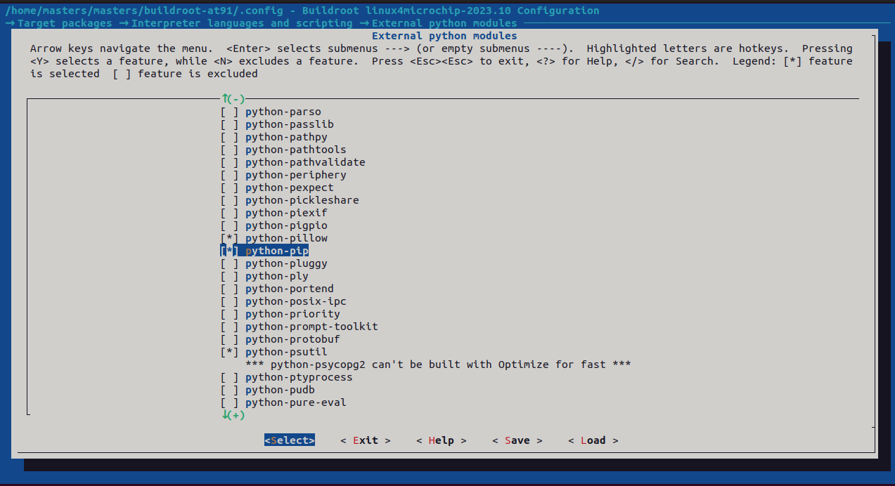

# Also select dropbear which is in Target Packages-> networking applications-> dropbear

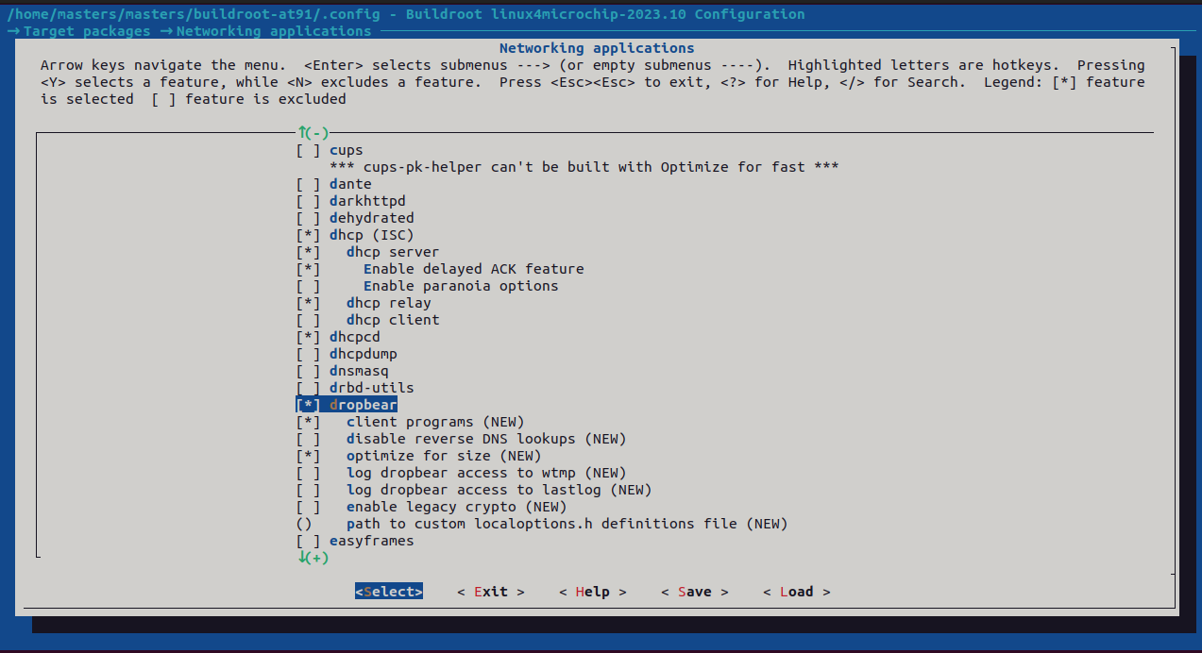

# We will now add the modifications for adding the MGC3140 driver.

# Use the reference file “mgc3140_gesture_patch.txt” that is provided in the lab resources.

# Do the necessary changes, save the configurations and build.

$ make

After a successful build…

 1. The SD card image (sdcard.img) for the SAM9X60-EK is available in the ~/buildroot-mchp/output/images directory.

2. The cross toolchain (arm-buildroot-linux-gnueabi-XX) is installed in the ~/buildroot-mchp/output/host/bin directory.

3. The sysroot directory containing the target headers, libraries, binaries, etc. are installed in the ~/buildroot-mchp/output/host/arm-buildroot-linux-gnueabi/sysroot directory

***Appendix B - Study and Understand the Classes and Functions used in the Application Code***

Please refer to the following Developer Help Page to install EGT Documentation: [EGT Documentation Installation - Microchip Developer Help Page](https://developerhelp.microchip.com/xwiki/bin/view/software-tools/linux/egt-prepare/)

**Application Class:**From ~/egt/docs/html/annotated.html, click on v1 and then Application class. All the functions, attributes and constructor associated with the Application class is documented here. The application class is a helper class that does standard setup for inputs, outputs, event loop, etc. In this project, we construct an Application and run it using the run() method to run the application. **TopWindow / Window Class:**From ~/egt/docs/html/annotated.html, click on v1 and then click on TopWindow or Window class. TopWindow is the main Window that provides functions like a pointer (cursor) that apply only to the top-level window. In this project, we use the show() method of the Window class to show the main window in which all widgets are drawn. Additionally, we use the **UiLoader** to load the user interface from an XML file and cast it to a Window pointer.  
  
This class represents a widget that handles drawing to a Screen. It can create different screens or frames within the application and serves as a container for various widgets like buttons, labels, and sliders. Windows manage visibility and layout to navigate between screens in the application.  
  
**Button Class:**  
From ~/egt/docs/html/annotated.html, click on v1 and then click on Button class. All the functions and constructor associated with the Button class is documented here. This class represents a basic button control that can be clicked to trigger actions. It inherits from TextWidget, allowing it to display text with UTF-8 encoding and multiline support. When constructing a button widget, you can provide the text to be displayed on the button.  
  
**ImageButton Class:**This class represents a button that contains both text and an image. It inherits functionality from the ImageHolder template, which combines the features of the Button class with image display capabilities. The position of the text is relative to the image, and the alignment of the text works as usual. If there is no text, the image is aligned relative to the position where the text would be. Layout rules dictate that when text is displayed, the autoscale feature does not affect the layout. The size of the button will be updated to accommodate the original size of the image plus extra space for the text, unless the auto resize feature is disabled. If a size is specified for the button and there is no text, the image will be scaled to fit the button size, with the option to maintain the original aspect ratio during scaling.  
  
**Slider Class:**

From ~/egt/docs/html/annotated.html, click on v1 and then click on Slider class. All the functions and constructors associated with the Slider class are documented here. This class represents a slider widget that allows users to select a value within a specified range. The Slider class inherits functionality from the ValueRangeWidget template, enabling it to manage a range of values. Users can customize the appearance and behavior of the slider by setting various properties such as color, size, and slider flags.  
  
  
**Label Class**

From ~/egt/docs/html/annotated.html, click on v1 and then click on Label class. All the functions and constructors associated with the Label class are documented here. This class represents a widget used for displaying text on the screen. With the Label class, users can create text elements with different content and alignment options. The Label class inherits functionality from the TextWidget class, providing features for rendering and managing text content. Users can customize the appearance and behavior of labels by specifying text alignment, font properties, and parent frames.

**ImageLabel Class**

From ~/egt/docs/html/annotated.html, click on v1 and then click on ImageLabel class. All the functions and constructors associated with the ImageLabel class are documented here. This class extends the functionality of the Label class by incorporating support for displaying images alongside text. Users can use the ImageLabel class to create widgets that combine both text and images in a visually appealing manner. By leveraging the ImageHolder template, the ImageLabel class enables seamless integration of images with text, allowing for flexible layout options and enhanced user interfaces.

**TextBox Class**:  
  
The TextBox class is a versatile input text box that supports UTF-8 encoding, cursor movement, text selection for copy or deletion, multi-line text, word wrapping, customizable alignment, optional virtual keyboard display, horizontal and vertical scrolling, input validation through callback functions, and provides comprehensive methods for text manipulation including insertion, deletion, cursor positioning, and text selection, along with built-in mechanisms for text layout computation and rendering, as well as interactive components like scrollbars for scrolling.

**AutoAnimation Class:**

The AutoAnimation class is a specialized animation class that includes a built-in timer to manage the animation's periodic updates. This class simplifies the creation and control of animations by automatically handling the timing and progression of the animation, allowing users to focus on defining the start and end values, the duration, and the easing function.  
  
**Handle Number Button Click (Lambda Function):**

The lambda function handleNumberButtonClick handles the click events for number buttons on a keypad. It appends the clicked number to an input string and updates a display with masked input (" * "). When four numbers are entered, it checks the input against a predefined PIN ("1212"). If the PIN is correct, it transitions from the keypad screen to the slider screen. If the PIN is incorrect, it transitions to the incorrect pin screen.  
  
**Setup Slider Value Function**:  
The setup_Slider_Value function customizes the behavior of a slider widget by adjusting its value based on a specified step increment and ensures that a label displays the correct, adjusted slider value. This function connects an event handler to the slider's value change event, dynamically updates the slider's value to a multiple of the step increment, and updates the label to reflect this value.  
  
**Setup Scrolling Text Animation Function:** The setup_ScrollingText_animation function configures a scrolling text animation within the main screen of an EGT application. It creates a label widget containing the scrolling text and applies animation to scroll the text horizontally across the screen. The direction of the animation can be specified as either from left to right or from right to left, providing flexibility in the visual presentation of the text. This function enhances the user interface by adding dynamic visual elements to the application  
  
**LED GPIO Functions:**  
  
The init_LED_GPIO function initializes GPIO pin 62, to which the LED pin of I/O1 Xplained Pro is connected, as an output pin for controlling an LED by opening the GPIO device and obtaining a handle for the pin. The LED_ON function sets GPIO pin 62 to a low state, turning on the connected LED (active low), by configuring the pin's data structure and using an ioctl command. Similarly, the LED_OFF function sets GPIO pin 62 to a high state, turning off the LED (active low), through similar data configuration and ioctl operations.

**Update Label with Timer Function:**The update_Label_with_Timer function updates multiple labels, each located at the top right corner of every screen in the application, with temperature readings using a periodic timer. The temperature readings are obtained from the **outfunction**, which retrieves the current temperature from a sensor. This function enhances the user interface by providing real-time temperature updates on various screens of the application.  
  
**External Temperature Reading Function:**  
The outfunction retrieves temperature readings from a sensor (I/O1 Xplained Pro) connected via I2C communication and returns the temperature value in Celsius. This function is designed to be used as an external function to obtain real-time temperature data from the sensor.  
  
  
  
**Functionality of cancel_incorrect_pin_button:**

When the "cancel_incorrect_pin_button" is clicked, it hides all screens except the main screen. This typically occurs when a user wants to cancel an action due to entering an incorrect PIN during a transaction.

**Functionality of retry_pin_button:**

When the "retry_pin_button" is clicked, it hides all screens except the keypad screen, allowing the user to retry entering the PIN. This is useful when a user wants to make another attempt at entering the correct PIN.

**Functionality of Get_cash_button:**

When the "Get_cash_button" is clicked and the slider value is greater than 0, it sets a GPIO pin high, hides all screens except the "Thank_you_screen", indicating successful transaction completion. This button is typically used to initiate a cash withdrawal transaction.

**Functionality of cancel_thank_you_button:**

When the "cancel_thank_you_button" is clicked, it hides all screens except the main screen. This typically occurs when a user cancels a transaction after it has been completed, returning to the main screent models in the future.

# Appendix C – Usage of argparse and tflite_runtime

1. Package: argparse

What is argparse? argparse is a Python module for parsing command-line arguments. It is part of the Python standard library from version 2.7 and above, so typically, you wouldn't need to install it separately. However, in cases where you're working with a minimal Python environment or an embedded system where some standard libraries might be missing, you might need to install it manually.

Why do you need argparse? In this application if you want to make your scripts more flexible by accepting command-line arguments, you would use argparse. It allows you to define what arguments your script requires, optional arguments, default values, and help messages.

1. Package: tflite_runtime

What is tflite_runtime? tflite_runtime is a lightweight package that allows you to run TensorFlow Lite models. It's a stripped-down version of the TensorFlow package, specifically designed for running inference on edge devices with limited resources.

Why do you need tflite_runtime? For your face detection project, you need to perform inference with a TensorFlow Lite model. Using tflite_runtime instead of the full TensorFlow package can significantly reduce the footprint and make your application more suitable for resource-constrained environments like the ATSAMA5D27-WLSOM1 board.

By understanding these packages and their roles, you can see how they enhance the functionality and flexibility. This knowledge will also help you adapt your application for different models and requirements in the future.

**Verifying Installation of argparse and tflite_runtime packages:**

you can verify whether the necessary packages for the face detection are installed using pip it will take some time for verifying the packages.

#### Step 1: Verifying argparse package:

Use the command

* *pip install argparse-1.4.0-py2.py3-none-any.whl*

and you should see results something like this if the packages are already installed:



#### Step 2: Verifying tflite_runtime package:

Use the command

* *pip install tflite_runtime-2.14.0-cp311-cp311-manylinux_2_34_armv7l.whl*

you should see results something like this:

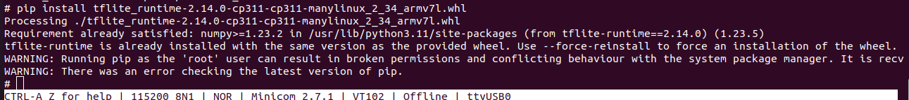

# Appendix D - Study and Understand Python Face detection Application Code

* **Imports and Class Initialization**
* **Imports:**
  + cv2: OpenCV library used for image processing.
  + numpy: Library for numerical operations.
  + tflite_runtime.interpreter: TensorFlow Lite interpreter for running the TFLite model.
  + mpio: Library for controlling GPIO pins.
* **Class Initialization (FaceDetector):**
  + Constructor (__init__): Initializes the face detector class with various parameters:
    - model_path: Path to the TFLite model.
  + input_size: Size to which input images are resized.
  + conf_threshold: Confidence threshold for detecting faces.
  + center_variance and size_variance: Parameters for bounding box adjustments.
  + nms_max_output_size and nms_iou_threshold: Parameters for non-maximum suppression (NMS).
* **Load TFLite Model:**
  + tflite.Interpreter: Loads the TFLite model.
  + allocate_tensors: Allocates memory for model tensors.
* **Input and Output Details:**
  + get_input_details and get_output_details: Fetches details about the input and output tensors.
* **Initialize GPIO Pin:**
  + Sets up a GPIO pin (self.led_pin) to control an LED.
* **Pre-processing Method (_pre_processing)**
* **Pre-processing:**
  + Resize Image: cv2.resize resizes the image to the input size expected by the model.
  + Convert to RGB: Converts the image from BGR to RGB format.
  + Normalize Image: Normalizes pixel values to the range [-1, 1].
* **Face Detection Method (detect_faces)**
* **Face Detection:**
  + Pre-process Image: Calls the _pre_processing method to prepare the image.
  + Set Input Tensor: Sets the pre-processed image as input to the model.
  + Invoke Interpreter: Runs the model to perform inference.
  + Get Output Tensors: Retrieves the bounding boxes and confidence scores from the model.
  + Post-process Results: Calls the _post_processing method to count the number of detected faces.
* **Post-processing Method (_post_processing)**
* **Post-processing:**
  + Count Faces: Counts the number of detected faces based on confidence scores.
  + Control GPIO 108 (PD12): Set the GPIO pin HIGH or LOW based on the number of detected faces.
  + Print Status: Prints "Secured" if the number of faces is less than 14, otherwise prints "Not Secured".
* **Cleanup Method (cleanup)**
* **Cleanup:**
  + Release GPIO Resources: Closes the GPIO pin.
* **Main Block:**
  + Define Model Path: Specifies the path to the TFLite model.
  + Create Face Detector Instance: Initializes the FaceDetector class.
  + Start Camera Capture: Opens a connection to the USB camera.
  + Capture and Process Frames: Continuously captures frames from the camera and processes them using the face detector.
  + Release Resources: Releases the camera and GPIO resources when done.
* **Concept Behind the Code**
  + Model Loading: The TFLite model is loaded and prepared for inference using the TensorFlow Lite interpreter.
  + Image Pre-processing: Input images are resized, converted to the appropriate color space, and normalized to match the model's input requirements.
  + Inference: The pre-processed image is fed into the model, which outputs bounding boxes and confidence scores for detected faces.
  + Post-processing: The results are processed to count the number of faces and control GPIO pins based on the number of detected faces.

**Writing New Code for a Different Model**

When using a different model, you need to consider the following:

* **Model Path:** Update the model_path with the path to the new TFLite model.
* **Input Size:** Ensure the input_size matches the expected input size of the new model.
* **Pre-processing Steps:** Adjust the pre-processing steps (resizing, normalization) if the new model requires different pre-processing.
* **Output Details:** Verify the output tensor indices and dimensions for the new model.
* **Post-processing Logic:** Modify the post-processing logic based on the output format of the new model.
* **Thresholds and Parameters:** Adjust confidence thresholds and NMS parameters if necessary.

**Example Modifications for a New Model:**

class FaceDetector:

def __init__(self, model_path, input_size=(300, 300), conf_threshold=0.5):

self.model_path = model_path

self.input_size = input_size

self.conf_threshold = conf_threshold

# Load the new TFLite model

self.interpreter = tflite.Interpreter(model_path=self.model_path)

self.interpreter.allocate_tensors()

# Get input and output details for the new model

self.input_details = self.interpreter.get_input_details()

self.output_details = self.interpreter.get_output_details()

# Initialize GPIO pin

self.gpio_pin = 108 # PD12 in ATSAMA5D27-WLSOM1 EK

self.gpio = mpio.GPIO(self.gpio_pin, mpio.GPIO.OUT)

def _pre_processing(self, img):

resized = cv2.resize(img, self.input_size)

image_rgb = resized[..., ::-1].astype(np.float32)

image_norm = (image_rgb / 127.5) - 1.0 # Adjust normalization if needed

return image_norm[None, ...]

# Rest of the methods remain the same

By following these steps and understanding the structure of the code, you'll be able to adapt the face detection code to work with different models in the future.

# Appendix E - Study and Understand popup and GPIO status monitoring code snippet

The following code is part of the main Graphics C++ application. The code snippet provided is written in C++ using the Ensemble Graphics Toolkit (EGT), which is used for creating popup screen based on GPIO status.

* **Calculate Popup Dimensions:**

 auto popup_width = window1.width() / 2;

auto popup_height = window1.height() / 2;

The width and height of a popup window are calculated to be half the width and height of an existing window, window1.

* **Create the Popup Window:**

egt::Popup popup(egt::Size(popup_width, popup_height));

popup.color(egt::Palette::ColorId::bg, egt::Palette::white);

A popup window (egt::Popup) is created with the dimensions calculated in the previous step. The background color of the popup is set to white.

* **Position the Popup Window:**

auto pos_x = (window1.width() - popup_width) / 2;

auto pos_y = (window1.height() - popup_height) / 2;

popup.move(egt::Point(pos_x, pos_y));

The position of the popup window is calculated to be centered within window1. The popup.move method positions the popup at the calculated coordinates.

* **Add a Title Label to the Popup:**

egt::Label title(popup, "Intruder Alert!!");

title.align(AlignFlag::expand_horizontal);

Font new_font("Serif", 26);

title.font(new_font);

title.color(egt::Palette::ColorId::label_text, egt::Color(255, 255, 255));

title.color(Palette::ColorId::label_bg, Palette::grey);

title.fill_flags(Theme::FillFlag::solid);

* + A label with the text "Intruder Alert!!" is added to the popup.
  + The label is aligned to expand horizontally.
  + A new font ("Serif", size 26) is applied to the label.
  + The text color of the label is set to white, and the background color is set to grey.
  + The label is set to fill its background solidly.

### 

* **Add a Button to the Popup:**

egt::Button button(popup, "Try again!!");

button.align(AlignFlag::center);

button.on_event([&](Event & event){

 if (event.id() == EventId::pointer_click)

{

cout << "clicked!" << endl;

popup.hide();

}

});

A button with the text "Try again!!" is added to the popup and centered. An event handler is attached to the button to respond to click events (EventId::pointer_click). When the button is clicked, the message "clicked!" is printed to the console, and the popup is hidden.

**GPIO status monitoring:**

This code snippet demonstrates how to monitor a GPIO pin for events using the Linux GPIO character device interface. When a specific GPIO event occurs, it triggers a modal popup and manipulates the visibility of different screens in a graphical user interface. Here's a broad explanation:

1. Open the GPIO Device:

int fd = open("/dev/gpiochip0", 0);

if (fd < 0)

{

std::cerr << "Failed to open /dev/gpiochip0" << std::endl;

return 1;

}

Opens the GPIO chip device file /dev/gpiochip0. If the file cannot be opened, an error message is printed, and the program exits with a status code of 1.

1. Request GPIO Event:

gpioevent_request ereq{};

ereq.lineoffset = 109; // GPIO pin 109 (PD13)

ereq.handleflags = GPIOHANDLE_REQUEST_INPUT;

ereq.eventflags = GPIOEVENT_REQUEST_BOTH_EDGES;

if (ioctl(fd, GPIO_GET_LINEEVENT_IOCTL, &ereq) < 0)

std::cerr << "GPIO_GET_LINEEVENT_IOCTL failed" << std::endl;

* A gpioevent_request structure is initialized.
* The lineoffset specifies the GPIO pin number (109 in this case, corresponding to PD13).
* The handleflags is set to request the GPIO line as an input.
* The eventflags is set to monitor both rising and falling edges.
* The ioctl function is used to issue a GPIO_GET_LINEEVENT_IOCTL request. If it fails, an error message is printed.

1. Get GPIO Line Value:

gpiohandle_data data{};

if (ioctl(ereq.fd, GPIOHANDLE_GET_LINE_VALUES_IOCTL, &data) < 0)

std::cerr << "GPIOHANDLE_GET_LINE_VALUES_IOCTL failed" << std::endl;

A gpiohandle_data structure is initialized. The ioctl function is used to issue a GPIOHANDLE_GET_LINE_VALUES_IOCTL request to get the current value of the GPIO line. If it fails, an error message is printed.

1. Monitor GPIO Events:

GpioEventMonitor monitor(ereq.fd, [&main_screen, &window, &popup, &Transaction_screen, &keypad_screen, &slider_screen, &incorrect_pin_screen, &Thank_you_screen](const gpioevent_data& event)

{

if (event.id == GPIOEVENT_EVENT_RISING_EDGE) // Check if GPIO status is LOGIC HIGH

{

popup.show_modal();

main_screen->show();

Transaction_screen->hide();

keypad_screen->hide();

slider_screen->hide();

incorrect_pin_screen->hide();

Thank_you_screen->hide();

}

window->on_event([&main_screen, &window, &Transaction_screen, &popup, &keypad_screen, &slider_screen, &incorrect_pin_screen, &Thank_you_screen](egt::Event & event) {

switch (event.key().keycode) {

case egt::EKEY_3: {

main_screen->show();

popup.hide();

Transaction_screen->hide();

keypad_screen->hide();

slider_screen->hide();

incorrect_pin_screen->hide();

Thank_you_screen->hide();

break;

}

default:

break;

}

}, {egt::EventId::keyboard_up});

});

* A GpioEventMonitor is created to monitor the GPIO events on the specified file descriptor (ereq.fd).
* When a rising edge event is detected on the GPIO pin, the following actions are taken:
  + The modal popup (popup) is shown.
  + The main_screen is shown.
  + Other screens (Transaction_screen, keypad_screen, slider_screen, incorrect_pin_screen, and Thank_you_screen) are hidden.

1. Handle Keyboard Events:

window->on_event([&main_screen, &window, &Transaction_screen, &popup, &keypad_screen, &slider_screen, &incorrect_pin_screen, &Thank_you_screen](egt::Event & event) {

switch (event.key().keycode) {

case egt::EKEY_3: {

main_screen->show();

popup.hide();

Transaction_screen->hide();

keypad_screen->hide();

slider_screen->hide();

incorrect_pin_screen->hide();

Thank_you_screen->hide();

break;

}

default:

break;

}

}, {egt::EventId::keyboard_up});

* This code block sets up an event handler for keyboard events on the window.
* The event handler checks for key presses. Specifically, it looks for the key with the keycode egt::EKEY_3.
* When this key is pressed (keyboard_up event), the following actions are taken:
  + The main_screen is shown.
  + The popup (popup) is hidden.
  + Other screens (Transaction_screen, keypad_screen, slider_screen, incorrect_pin_screen, and Thank_you_screen) are hidden.

# Appendix F – Installing Face.py and graphics application as system services

Run the Graphics Application automatically from the boot process. This can be achieved with a systemd service.

##### Step 1.1: Creating the Service

* **Systemd** is a **system** and **service** manager for Linux. To find the existing system services, navigate to /etc/systemd/system/multi-user.target.wants
* remove the existing service file for egt using the following command
  + *rm -rf egtdemo.service*

The existing egtdemo.service is by default present in the demo image.We are deleting and creating a new service.

* now navigate to the /etc/system/system/
  + create a new service using the following command
  + *nano egtdemo.service*

##### Step 1.2: Copy the following script into the new file egtdemo.service:

[Unit]

Description=EGT Application Launcher Service

After=network.target

ConditionPathExists=/dev/dri/card0

[Service]

Type=simple

ExecStart=sh -c '/root/lnx3_masters'

RemainAfterExit=yes

Restart=on-failure

[Install]

WantedBy=multi-user.target

After the changes, the script should look something like this:

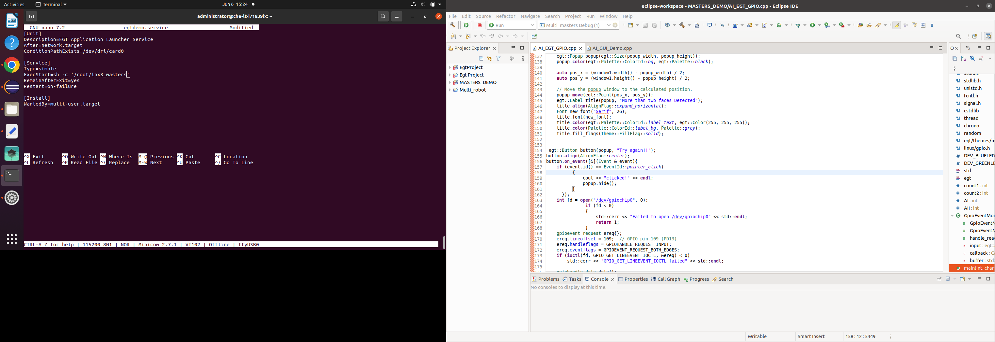

##### Step 1.3: Save the changes

* You can save the changes by entering the following commands
  + - * + *Ctrl + x*
        + *Y (enter Y for saving the changes)*
        + *Press Enter( to keep the file name)*

##### Step 1.4: We have now created a system service. Run the following command to reload the daemon.

* + - * + *systemctl daemon-reload*

##### Step 1.5: To enable the service, run the following command

* + - * + *systemctl enable egtdemo.service*

##### Step 1.6: To start the service run the following command

* + - * + *systemctl start egtdemo.service*

After running the above command, you should be able to see the Graphics Demo running on LCD.

##### Step 1.7: To stop the service run the following command

* + - * + *systemctl stop egtdemo.service*

After running the above command, you should be able to stop the Graphics Demo.

#### Step 2: Similarly Run the AI demo using the systemd service

##### Step 2.1: The new service should look something like this

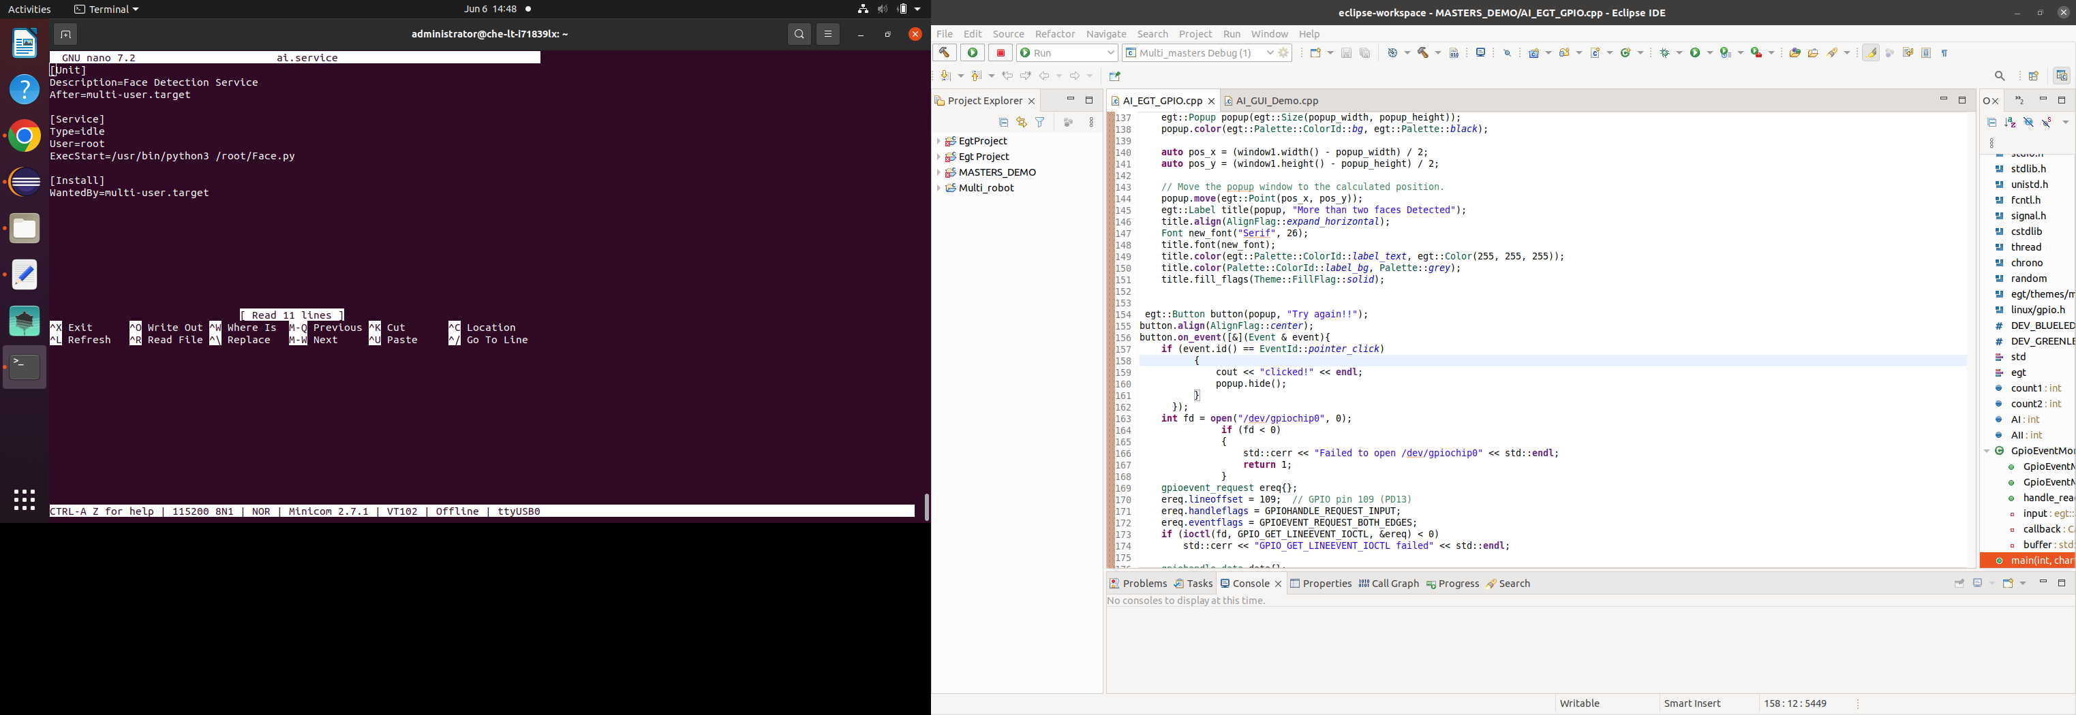

##### Step 2.2: Now we created service. Run the following command to reload the daemon.

* + - * + *systemctl daemon-reload*

##### Step 2.3: To enable the service, run the following command

* + - * + *systemctl enable ai.service*

##### Step 2.4: To start the service run the following command

* + - * + *systemctl start ai.service*

Once you write a new service you should be able to RUN both the Face detection demo and Graphics demo automatically after system boot.